
Pupil premium strategy statement 2026-27

This statement details our school’s use of pupil premium funding to help improve the attainment of our disadvantaged pupils.

It outlines our pupil premium strategy, how we intend to spend the funding in this academic year and the effect that last year’s spending of pupil premium had within our school.

School overview
Detail | Data
School name | Moor End Community Primary School
Number of pupils in school | 208 (including pre school)
Proportion (%) of pupil premium eligible pupils | 46%
Academic year/years that our current pupil premium strategy plan covers (3 year plans are recommended) | 2025-2028
Date this statement was published | Autumn 2026
Date on which it will be reviewed | Autumn 2027
Statement authorised by | Philip Sumner
Pupil premium lead | Hannah Clugston
Governor / Trustee lead | Jenna Parkington
Funding overview
Detail | Amount
Pupil premium funding allocation this academic year | £127,580
Recovery premium funding allocation this academic year | £0
Pupil premium funding carried forward from previous years (enter £0 if not applicable) | £0
Total budget for this academic year  If your school is an academy in a trust that pools this funding, state the amount available to your school this academic year | £127,580

Part A: Pupil premium strategy plan

Statement of intent
For a full outline of our ethos and purpose of intent towards meeting the needs of our pupil premium children, please read our extensive Pupil Premium Ethos Document in conjunction with this statement.

As a fully inclusive school, we are committed to supporting all our pupils to be ‘Ready, Respectful and Safe’. We also challenge our pupils to show the values of CARE: Confidence, Acceptance, Resilience and Enjoyment.
Around 46% of our pupils have been identified as disadvantaged. This informs our approach to pupil premium spending in that we prioritise strategies that impact on the majority of our children, however we specifically consider those pupils who are deemed to be at a disadvantage educationally.
Our intention is that all pupils, irrespective of their background or the challenges they face, make good progress and achieve high attainment across all subject areas. The focus of our pupil premium strategy is to support disadvantaged pupils to achieve that goal, including progress for those who are already high attainers.
By supporting pupils who need support the most, we will continue to target this funding in areas of disadvantage to ensure that all children, regardless of their background can achieve their full potential. We are continuously driving for improvement.
Quality first teaching is therefore at the core of our approach. This is proven to have the greatest impact on closing the disadvantage attainment gap and at the same time, will benefit the non-disadvantaged pupils at Moor End (EEF research: The EEF Guide to Pupil Premium). Our approach is responsive to the common challenges we experience and individual needs. This is rooted in well-established diagnostic assessments and not assumptions about the impact of disadvantage.
Our strategy is also integral to wider school plans for education including targeted intervention support for pupils, including non-disadvantaged pupils. The approaches we have adopted complement each other to help pupils excel. To ensure they are effective we will:
- ensure disadvantaged pupils are challenged in the work that they’re set
- act early to intervene at the point need is identified
- adopt a whole school approach in which all staff take responsibility for disadvantaged pupils’ outcomes and raise expectations of what they can achieve

Challenges

This details the key challenges to achievement that we have identified among our disadvantaged pupils.
Challenge number | Detail of challenge
1 | Many disadvantaged children enter school with limited communication and language skills, resulting in a slower start to their education. Our observations and assessments identify a low baseline in oral communication, language and literacy. Our internal data shows that this has an impact on children’s reading and writing and the overall good level of development (GLD).
2 | Family lives can be chaotic and social services are often involved. Many of our children reside in areas where the multiple deprivation index is E and where aspects such as employment, health and living environment is in band E overall. 17% of our children reside in areas with an overall deprivation index of E*, the lowest 5% in the country. Because of this, many PP children do not have the social and emotional resilience to allow them to focus on academic matters. We have seen a rise in pupils requiring pastoral and mental health support.
3 | PP children commonly come into school with fewer experiences to draw upon and relate to from their wider life experiences, limited cultural capital and low aspirations for their own future, meaning that they struggle to engage with the school curriculum on a level that is meaningful to them.
4 | After analysing our attendance and punctuality, we have identified challenges in regards to our PP children both attending school and also being on time.

Intended outcomes
This explains the outcomes we are aiming for by the end of our current strategy plan, and how we will measure whether they have been achieved.
Intended outcome | Success criteria
Communication and language skills for disadvantaged children to progress rapidly, in order that they leave EYFS with the expected level of development in these areas, and progress through school with speech & language skills that allow them to fully access to the curriculum. Additional support through support hub for speech and language through a SALT expert. | PP children make accelerated progress with their speech, language and communication needs and leave EYFS with the expected level of development.  Assessments (Wellcomm, NELI, LLLI and SALT reports) indicate significantly improved communication and language skills.
To provide a network of social and emotional support for PP children, enabling them to develop increased resilience to the challenges they face. | PP children’s social and emotional needs are addressed and children are more resilient to challenges.  Qualitative data from pupil voice, pupil and parents questionnaires and teacher observations show children have increased resilience to the challenges they face.  Observations of children’s engagement in learning shows they have a ‘can do’ attitude and self-belief resulting in increased resilience.
Provide a deeply enriched curriculum to ensure that all PP children have real experiences to draw upon and apply to their learning and opportunities to raise their aspirations and awareness of wider opportunities. | PP children have higher aspirations and a greater awareness of wider opportunities available to them to improve opportunities for the future.  Cultural capital experiences (visits and visitors included) are planned and embedded into our curriculum. A wide range of free (or low cost) extra-curricular activities are available to all pupils.
Improved attendance and punctuality of our PP children. | Attendance above National Average but also in line with our whole school attendance.

Activity in this academic year
This details how we intend to spend our pupil premium (and recovery premium funding) this academic year to address the challenges listed above.

Teaching (for example, CPD, recruitment and retention)
Budgeted cost: £54,821
Activity | Evidence that supports this approach | Challenge number(s) addressed
Communication and Language  Wellcomm assessment used with all EYFS pupils to identify communication / language baselines and to measure progress made  ELSA intervention from HLTA in support hub for EYFS  NELI intervention implementation (targeted) and training impacting all  Overstaffing in EYFS to increase communication modelling and dialogue in continuous provision and small group work.  SALT expertise from HLTA in support hub. | Detailed research into appropriate assessment and intervention tools using EEF recommendations and evidence based upon previous years trials with Speech and language therapist, Wellcomm and NELI.  Consistently good provision (environment, assessments & practice) provides communication experiences, language development, reading and writing progress.  The systemic review commissioned by the EEF ‘Early Language Development’ reinforces the above approaches to be in line with best practice, especially in terms of adult interactions – hence the need for additional staff to model this.  EEF EY Toolkit Evidence: Overall, studies of communication and language approaches consistently show positive benefits for young children’s learning, including their spoken language skills, their expressive vocabulary and their early reading skills. On average, children who are involved in communication and language approaches make approximately six months’ additional progress over the course of a year.  The EEF toolkit states that Oral Language impact development (Average impact +5 months)  NELI has been robustly analysed and evaluated and has shown that children make an additional 3 months in their language development. | 1 and 3
Purchase of standardised diagnostic assessments.  Training for staff to ensure assessments are interpreted and administered correctly.  Training for staff in gross motor skills screening. | Standardised tests can provide reliable insights into the specific strengths and weaknesses of each pupil to help ensure they receive the correct additional support through interventions or teacher instruction:  Standardised tests | Assessing and Monitoring Pupil Progress | Education Endowment Foundation | EEF | 1
Improve the quality of social and emotional (SEL) learning.  SEL approaches will be embedded into routine educational practices and supported by professional development and training for staff.  Learning mentor to deliver Kidsafe to every class | There is extensive evidence associating childhood social and emotional skills with improved outcomes at school and in later life (e.g., improved academic performance, attitudes, behaviour and relationships with peers):  EEF_Social_and_Emotional_Learning.pdf( educationendowmentfoundation.org.uk) | 2
Targeted support – TA and use of the HLTA within the support hub. | Close data analysis (Termly) to identify children needing additional support.  TA appraisals to ensure CPD matches the needs of the children and the school. | 1 and 2

Targeted academic support (for example, tutoring, one-to-one support structured interventions)
Budgeted cost: £ 30,000
Activity | Evidence that supports this approach | Challenge number(s) addressed
Wellcomm intervention used to improve communication, language and vocabulary in EYFS  Targeted group work in Nursery and Reception using Wellcomm  ELSA delivered by HLTA in EYFS.  SALT support- Specialist teachers bought in through local SEND service.  Teachers to target assessment and support for those eligible for PP who are identified as having SEND  Intervention groups led by TA’s based on same day interventions, TT Rockstar’s, Phonics interventions  All teachers to complete TALK Lancashire courses to enable high quality first teaching.  Intervention groups for gross motor screening. | EF EY Toolkit Evidence: Overall, studies of communication and language approaches consistently show positive benefits for young children’s learning, including their spoken language skills, their expressive vocabulary and their early reading skills.  On average, children who are involved in communication and language approaches make approximately six months’ additional progress over the course of a year (EEF).  The EEF toolkit states that Oral Language impact development (Average impact +5 months), and phonics approaches have a moderate impact (+4 months) for a very low cost.  ShREC approach with EYFS staff to promote and support high quality interactions.  EEF toolkit: Small Group Work (Average impact +4 months), Feedback (high impact for very low cost +8 months)  Children identified through gross motor screening receive targeted intervention to develop their balance, coordination, strength and gross motor skills, increasing their confidence and ability to participate successfully in PE and wider physical activities. Progress is monitored to ensure identified gaps are addressed. | 1

Wider strategies (for example, related to attendance, behaviour, wellbeing)
Budgeted cost: £ 42,750
Activity | Evidence that supports this approach | Challenge number(s) addressed
School staffed with Pastoral team, DSL’s and Mental Health First aiders  Nurture sessions to support pupils emotional resilience  Experiences and visitors planned for all pupils across the year  Provide a wide range of extra-curricular activities, the vast majority of which are cost free, to allow children to participate experiences that are not provided within the home environment  Retain the appointment of full time Learning Mentor and increase her hours to include holiday weeks. | EEF toolkit identifies that the following all have a positive impact.  Behaviour intervention (moderate impact +3 months)  Social and Emotional Development (Average impact +4 months)  Metacognition and Self regulation strategies (+ 7 months)  Outdoor adventure learning (+4 months)  Kidsafe delivered by the learning mentor to every class.  Breakfast club for identified DAP and vulnerable children at 8.30am  Pastoral support for individual children and families is far beyond those identified DAP families  Close working with parents so that they admit when additional support is required. | 2,3 and 4

Total budgeted cost: £ 127,580

Part B: Review of outcomes in the previous academic year

Pupil premium strategy outcomes
This details the impact that our pupil premium activity had on pupils in the 2021 to 2022 academic year.
We have analysed the performance of our schools’ disadvantaged pupils during the 2024/25 academic year using phonics check results, key stage 1 and 2 performance data and our own internal assessments.
To support all pupils, including PP children, assessment focus has been on using internal data from our tracking system (Insight) for each year group, which has been monitored and moderated robustly internally and monitored through pupil progress meetings.
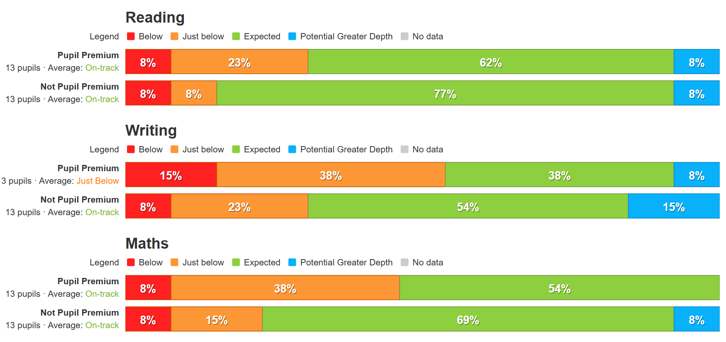
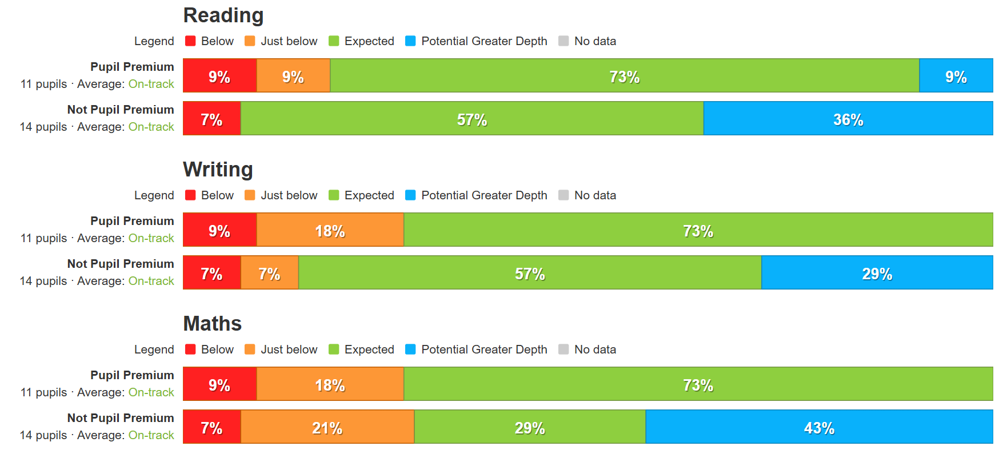
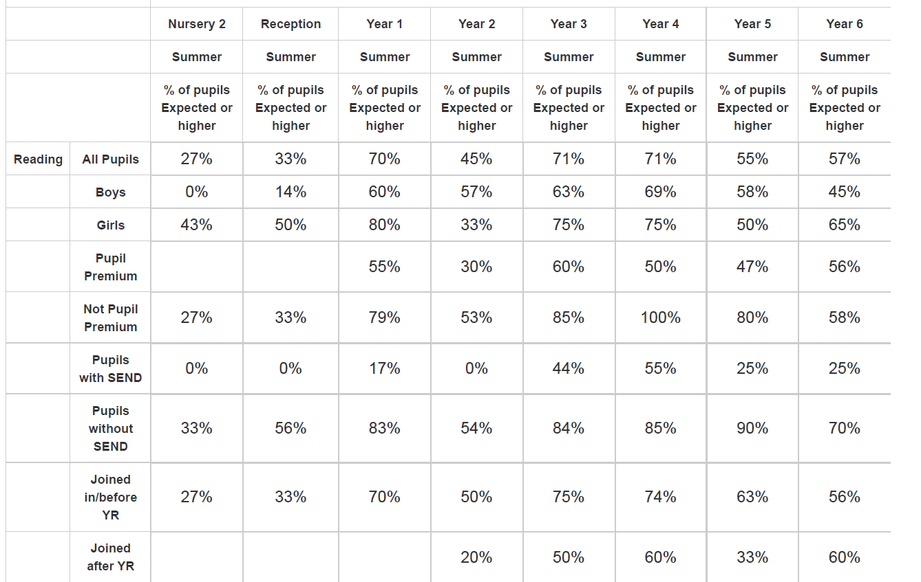
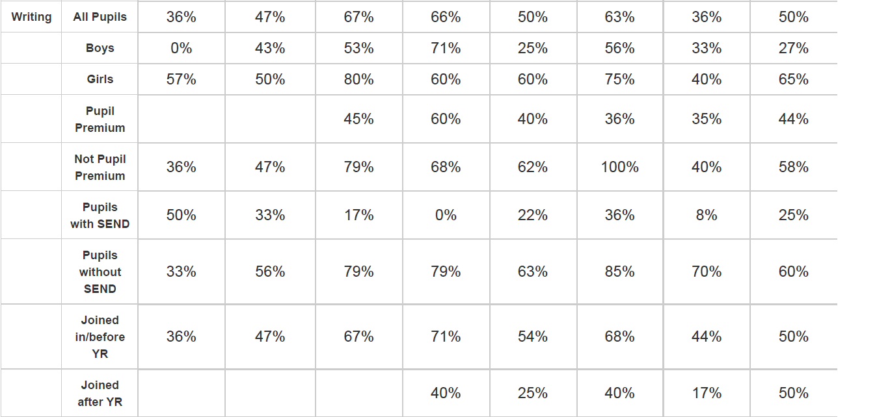
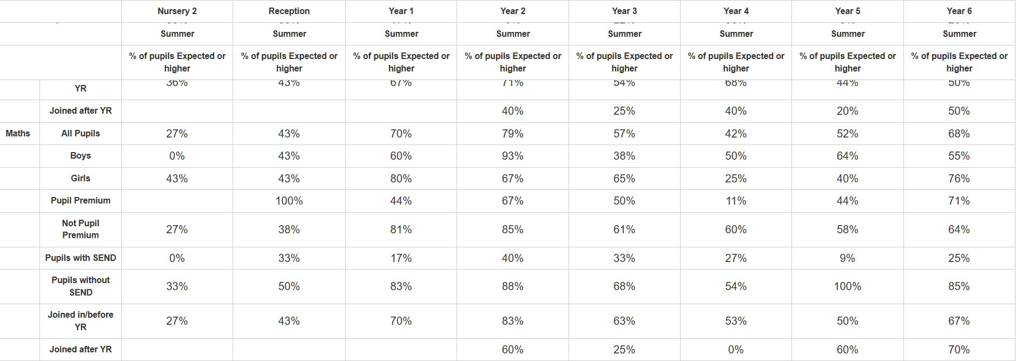

Through monitoring, both PP lead and class teachers know the needs of their PP pupils and have planned accordingly throughout the academic year. Current assessments have then been used to inform this strategy document for the academic year 2025/26 year, ensuring the most seamless learning possible. This can be ratified via internal assessment systems.
As can be seen by the data above, the pupil premium children in school, are working on average, just below the non pupil premium peers. With the difference being miniscule, it shows what we are doing is working and the impact we are having is across the board and not just for PP children.
Pupils were fully engaged in a wide range of trips and experiences which enriched the curriculum and gave them opportunities to widen their experiences and raise their aspirations. PP children engaged in a range of sporting activities which gave them opportunities to try new sporting activities.
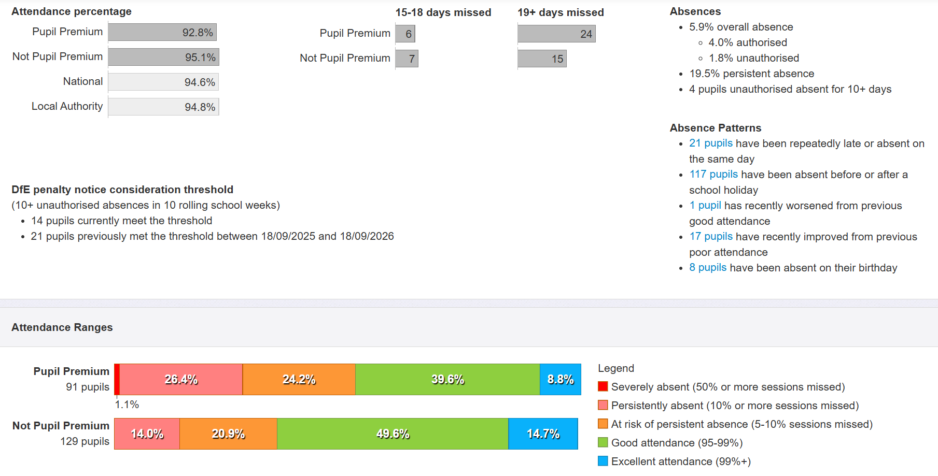
Our observations and assessments demonstrated that pupil behaviour improved last year, but challenges in relation to wellbeing and mental health remain significantly high. Through school, we are having more and more children with more complex additional needs and this is having an impact on behaviour through school. This is one of the reasons why we now have two SENCO’s in school.
We have reviewed our strategy plan and made changes to how we intend to use some of our budget this academic year, as set out in the Activity in This Academic Year section above. The Further Information section below provides more details about our planning, implementation, and evaluation processes.

Externally provided programmes
Please include the names of any non-DfE programmes that you purchased in the previous academic year. This will help the Department for Education identify which ones are popular in England
Programme | Provider
TT Rockstars | TT Rockstars
Learning by Questions | Learning by Questions
Spelling Shed | Ed Shed
Lancashire Talk Planning courses | Lancashire English team
KAPOW | KAPOW
White Rose subscription for premium resources | White Rose
Numbots | Numbots
Red Rose Phonics | Lancashire English Team

Further information (optional)
When dealing with disadvantage within a school community, happiness and academic success are not mutually exclusive. To achieve this you have to know your community very well and to do this you spend a long period asking your community what they really want. The data such as eco social indicators can point you in the right direction and give you an idea of the underlying factors or barriers to learning; however they are very often out of the control of school’s influence.
The strength of our methods are to recognise there are many factors we cannot control, e.g. social housing, unemployment rates etc., therefore we only focus on those things we can influence. We can influence and have an impact on the experiences our children receive, we can provide them with a voice, and we can provide a learning mentor to support those vulnerable families who don’t know which way to turn.
The underlying strength of our methods and approach is that we will do something that we know we can achieve. In effect it is a very ‘can do’ mentality. There is no point in wasting time and resources to change something that we can’t.
Our pupil premium strategy will be supplemented by additional activity that is not being funded by pupil premium or recovery premium. That will include:
- Embedding more effective practice around feedback. EEF evidence demonstrates this has significant benefits for pupils, particularly disadvantaged pupils.
- Completion of various NPQ’s to ensure our staff are staying up to date with relevant training.
- Utilising a DfE grant to train a senior mental health lead. The training we have selected will focus on the training needs identified through the online tool: to develop our understanding of our pupils’ needs, give pupils a voice in how we address wellbeing, and support more effective collaboration with parents.
- Offering a wide range of high-quality extracurricular activities to boost wellbeing, behaviour, attendance, and aspiration. Activities will focus on building life skills such as confidence, resilience, and socialising. Disadvantaged pupils will be encouraged and supported to participate.
Planning, implementation, and evaluation
In planning our new pupil premium strategy, we evaluated why activity undertaken in previous years had not had the degree of impact that we had expected.
We triangulated evidence from multiple sources of data including assessments, engagement in class book scrutiny, conversations with parents, students and teachers in order to identify the challenges faced by disadvantaged pupils.
Through completing our NPQ’s, we looked at a number of reports, studies and research papers about effective use of pupil premium, the impact of disadvantage on education outcomes and how to address challenges to learning presented by socio-economic disadvantage. We also looked at studies about the impact of the pandemic on disadvantaged pupils.
We used the EEF’s implementation guidance to help us develop our strategy. We treat implementation as a process, not an event; plan and execute it in stages. We will ensure we allow enough time for effective implementation, particularly in the preparation stage and prioritise appropriately.
We have put a robust evaluation framework in place for the duration of our three-year approach and will adjust our plan over time to secure better outcomes for pupils.

