Moor End Community Primary School
Curriculum overview
Year 6

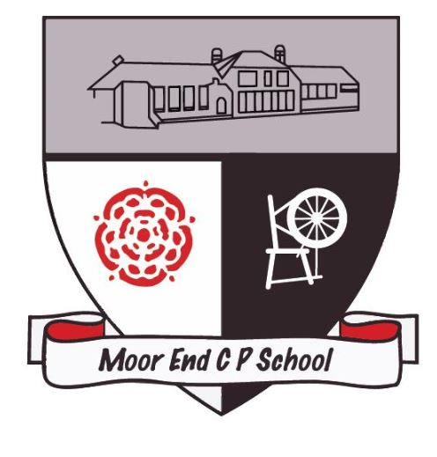

Year 6 | Autumn 1 | Autumn 2 | Spring 1 | Spring 2 | Summer 1 | Summer 2
Maths | We follow the White Rose curriculum.  Please see the maths page for an in depth look into our curriculum.
Class novels read throughout the year | 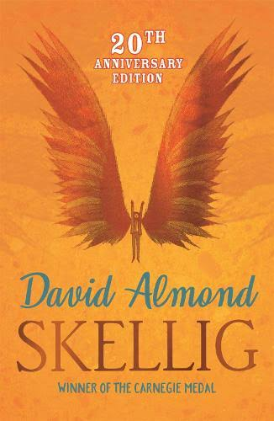  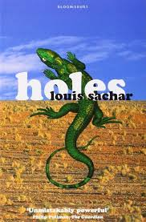  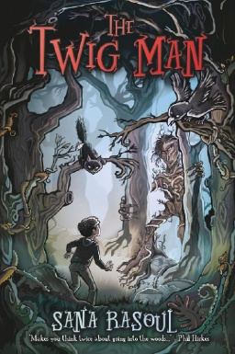  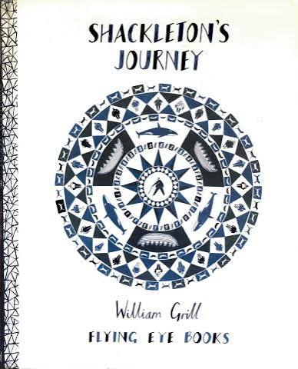  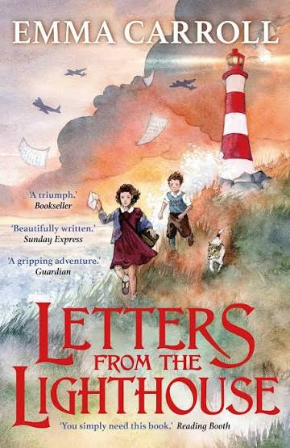  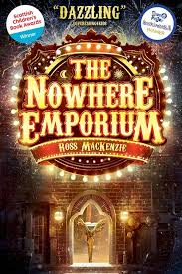
English | Letters From the Lighthouse  Diary Extract  Letters  Newspaper  Short Story | Biography Unit  Write a Biography for Shackleton  Formal Letters  Persuasion  The Dreadful Menace  Winter poems | The Nowhere Emporium  Diary Entry  Persuasive posters | The Twig Man  Short film clip :Alma Literacy Shed  Character description  Setting description  Short Gothic mystery | Revision SATS  Short film clip: The Road’s End Literacy Shed  Short story. | Writing consolidation
History | British 6: What was the impact of WW2 on the people of Britain? |  | What does the Census tell us about our local area? |  | Unheard histories: Who should go on the banknote?  Or The Sikh Empire
Geography |  | Why does population change? |  | Where does our energy come from? |  | Can I carry out an independent fieldwork enquiry?
Science Year 6 | Light | Electricity | Human Body | Additional investigations where’s needed | Living things in their environments | Evolution and inheritance
Computing Year 6  KAPOW | Computing systems and networks: Bletchley Park and history of computers | AI unit | Data handling:  Big data 1 | Programming:  Intro to Python | Data handling: Big data 2 | Skills showcase:  Inventing a product
Art focus  Year 6  KAPOW | Craft and design-  Photo opportunity |  | Drawing-  Make my voice heard |  | Sculpture and 3D-  Making memories
DT focus  Year 6  KAPOW |  | Textiles-  Waistcoats |  | Structures- Playgrounds |  | Digital world- Navigating the world
Additional lessons to cover in the year:
Come dine with me (DT)
Painting and mixed media: Artist study (Art)
RE Year 6 | Christianity (Church)  How do Christians mark the ‘turning points’ on the journey of life?  Christian rites of passage,  differences | Hindu dharma  Is there one journey or many?  Reincarnation,  Karma,  the 4 ashramas | Islam  What is Hajj and why is it important to Muslims?  The Ummah,  Hajj | Christianity (Jesus)  Why do Christians believe Good Friday  is ‘good’?  Holy Week,  The Eucharist  Denominational differences | Judaism  Do people need laws to guide them?  The Torah,  the synagogue | Christianity (God)  If life is like a journey, what’s the destination?  Salvation,  Forgiveness
PE Year 6  GetSet4PE | Netball and fitness | Dance and fitness | Gymnastics and fitness | Tennis and fitness | Orienteering and fitness | Athletics and cricket
Music Year 6  KAPOW | Dynamics, pitch and tempo (Fingal’s Cave) |  | Theme and variations (Pop Art) |  | Baroque | Composing and performing a leavers song
PSHE Year 6  KAPOW | Family and relationships | Health and wellbeing | Citizenship | Economic wellbeing | Safety and the changing body | Identity
Spanish Year 6 | Clothes in Spanish | School subjects in Spanish | Robots | Shopping in Spain | Freetime in Spain | Maya city treasure hunt

