
Moor End Community Primary School

Attendance policy 2024 - 26

Date of policy: Sep 2024

Date of review: Sep 2026

Contents

1 Introduction
2 Responsibilities and expectations
2.1 Families
2.2 School (including contact information for attendance-related matters)
2.3 Lancashire County Council
3 Types of absence
3.1 Authorised absences
3.2 Unauthorised absences
3.3 Persistent Absence (PA)
3.4 Severe Absence (SA)
3.5 Leave during term time
3.6 Religious absence
3.7 Participation in sporting events
3.8 Participation in performances
4 Registration
4.1 Attendance registration
4.2 Late arrival
4.3 Punctuality
5 School attendance procedures
5.1 First day of absence
5.2 Attendance concerns
5.3 Pupils with medical needs who have difficulty attending school
5.4 Pupils refusing to attend school
5.5 Promotion of good attendance
5.6 Use of penalty notices and other attendance legal interventions
6 Alternative provision and use of directions
7 Notifications school must submit to the local authority
7.1 Admissions
7.2 Leavers
7.3 Pupils who fail to attend
7.4 Pupils on a part-time timetable
7.5 Children missing education
Appendix: School attendance and the law
Parents and carers
Schools

1 Introduction

Moor End is a successful school and every child plays their part in making it so. We aim for an environment which enables and encourages all pupils to achieve their potential and aspire to excellence.
For our children to gain the greatest benefit from their education it is vital that they attend regularly and every child should be at school, on time, every day the school is open unless they have an unavoidable reason to be absent. Any absence affects the pattern of a child’s schooling and regular absence will seriously affect their learning.
Absence or late arrival also disrupts teaching routines and so may affect the learning of others in the same class.
Government research shows a direct link between attendance and attainment and good attenders also make better progress socially, learn to work with others, and are better prepared for the transition to secondary school and, eventually, higher education, training and employment.
It is very important therefore that you make sure that your child attends regularly and this policy sets out how together we will achieve this.
Our school attendance target this year is 96%, but all pupils should strive to achieve 100% attendance if they can.

2 Responsibilities and expectations

2.1 Families

Parents and carers have a legal duty to ensure that their children attend school regularly, if they are of compulsory school age and registered at a school (see the appendix for details of how the law applies to school attendance and how "parent" is defined in law).
Parents and pupils should know the times the school day starts and finishes and when the register closes (see section 4, below), the processes for requesting leave (see section 3.5), and the process for informing school of the reason for unexpected absence (as follows).
If your child is going to be absent, parents must inform school as soon as possible and at the latest by 9.15am on the first day of absence by calling school on 01254 233312.
Parents must also ensure that school has up-to-date contact information for themselves and emergency contacts.
Pupils' responsibilities depend upon their age, maturity and capability but they too must do their best to attend school regularly and punctually.

School contact information for attendance-related matters is given below at the end of section 2.2.

2.2 School

Head Teacher- Mr Sumner

- Ensure there are designated staff with day-to-day responsibility for attendance matters and protected time allocated to discharge those responsibilities.
- Take overall responsibility for ensuring the school confirms to statutory requirements regarding attendance.
- Consider each request for leave against the school's criteria, decide whether some, all, or none of the leave will be authorised and notify parents of this decision.
- Where there is uncertainty regarding an absence, make the decision whether or not to authorise an absence, or to request further evidence to support the decision-making process.
- Provide regular reports to the governing body on school attendance, including persistent absence and vulnerable groups.

Senior Attendance Champion- Mr Sumner

- Take overall responsibility for championing and improving attendance in school, liaising with pupils, parents and external agencies where needed.
- Set a clear vision for improving and maintaining good attendance.
- Establish and maintain effective systems for tackling absence and make sure they are followed by all staff
- Have a comprehensive understanding of attendance data.
- Use attendance data to target attendance improvement efforts and support to the pupils or pupil cohorts who need it most.
- Regularly monitor and evaluate progress, including the efficacy of the school’s strategies and processes.
- Regularly communicate pupil attendance and punctuality levels to parents.

Other staff with designated responsibilities for attendance

- First day response: contact parents if a reason for absence has not been provided and record this information accordingly. Contact emergency contacts if parents cannot be reached.
- Update attendance registers.
- Regularly monitor and analyse data to identify pupil, class and whole school attendance concerns and to target attendance improvement support for those who need it most, particularly vulnerable groups.
- Discuss attendance concerns at an early stage with pupils and parents.
- Work with pupils and parents to remove barriers to regular and punctual attendance, using attendance contracts where appropriate.
- Involve external agencies to support pupils and parents as appropriate to better understand and address the issues causing attendance concerns.
- Promote regular attendance through the school newsletter, website and displays and ensure the school's attendance policy is readily accessible.
- Use projects and strategies to improve attendance and punctuality for groups, classes or the whole school (eg incentive and reward schemes, certificates, traffic light letters).

All school staff

- Provide a welcoming atmosphere for pupils and a safe learning environment, particularly for those returning to school following a period of absence.
- Be aware of factors that can contribute to poor attendance and punctuality.
- Recognise that absence is a symptom of other issues impacting a pupil’s welfare and can be a warning sign of safeguarding concerns.
- Adhere to the procedures in place within school to promote good attendance.
- Promote the link between attendance and educational attainment to pupils and parents.
- Complete attendance registers in accordance with the legislation and under the direction of the head teacher.
- Raise any concerns about attendance with the attendance team and/or the headteacher.

Governors

- Ensure compliance with The School Attendance (Pupil Registration) (England) Regulations 2024.
- Agree an attendance policy and review it annually or more frequently if required.
- Agree targets for attendance at Moor End.
- Where the school is not meeting its attendance targets, or when the governors believe there is cause for concern, instigate a review of school's attendance procedures.
- Authorise the head teacher (or other designated person) to make decisions regarding leave of absence requests.
- Work with the head teacher in establishing equitable and consistent criteria against which leave requests will be considered.

Schools are bound by a range of attendance legislation, regulations and guidance; please see the appendix for further details.

School attendance contacts

Pamela Clugston, Amelia Dawson and Laura Ridealgh– contacts for parents to notify of pupils absence and day to day enquiries about attendance.

Philip Sumner, Headteacher: senior leader responsible for the strategic approach to attendance in school, with the support of Pamela Clugston, Amelia Dawson and Laura Ridealgh, Learning Mentor

The staff named above can be contacted on 01254 233312.

2.3 Lancashire County Council (the local authority)

School Attendance Support Team

Each school has a named contact in the School Attendance Support Team who can advise schools on attendance related matters, and with whom Targeting Support Meetings will be held. For mainstream nursery, primary and secondary schools this will be a School Attendance Support Worker (SASW); for special schools, short stay schools and pupil referral units (PRUs) this will be a School Attendance Consultant (SAC).

School Attendance Legal Team (SALT)

Following requests from schools for legal interventions when parents fail to ensure their children attend regularly, the School Attendance Legal Team undertakes enforcement processes, including penalty notices, prosecutions, parenting orders, education supervision orders and school attendance orders.

Children Missing Education (CME) Team

The Children Missing Education Team ensures the local authority fulfils its statutory duty to identify children in their area who are not registered pupils at a school and are not receiving suitable education otherwise than at a school. For further information see section 7, below, regarding notifications schools must submit.

3 Types of absence

Every half-day absence from school is classified by the school as either authorised or unauthorised. This is why information about the cause of any absence is always required from parents/carers.

3.1 Authorised absences

Authorised absences are mornings or afternoons away from school for a good reason like illness, medical/dental appointments which unavoidably fall in school time, emergencies, or other unavoidable causes or exceptional circumstances.

The NHS has guidance to help parents assess if their child is well enough to attend school: Is my child too ill for school? - NHS (www.nhs.uk).

3.2 Unauthorised absences

Unauthorised absences are those which the school does not consider reasonable or justifiable. If school has followed its attendance procedures and a pupil continues to have unauthorised absences, the school may see seek advice from the local authority School Attendance Support Team or request legal interventions from the School Attendance Legal Team. Examples of unauthorised absences are:

- Parents/carers keeping their child off school unnecessarily.
- Absences which are not explained satisfactorily.
- Pupils who arrive at school after the register has closed and without a legitimate reason (see section 4.2).
- Days off for shopping, birthdays or looking after other children.
- Day trips and other leave in term time which have not been agreed by the head teacher.
- Days that exceed an amount of leave agreed by the head teacher.

It is the head teacher's responsibility to decide if an absence is authorised or unauthorised and, if there is any uncertainty relating to an absence, school may request further confirmation from parents before an absence is authorised. For absence due to illness, this may be in the form of:
- Sight of an appointment for your GP or for the hospital, clinic, etc.
- Sight of prescribed medication or prescription for medication.
- Sight of medical notes/records.
- A letter from a medical professional such as a specialist or consultant.
- School's medical evidence slip, authorised by a pharmacist, doctor, receptionist, etc, which indicates that you have sought medical advice and outlines your child's medical condition.

Parents should not ask their doctor (GP) to provide "sick notes" to excuse absence.
Whilst any child may be off school because they are ill, sometimes they can be reluctant to attend school for other reasons. If your child is reluctant to attend it is better to speak to school as soon as possible to resolve the issue, rather than trying to cover up their absence, or give in to pressure to let them stay at home. As a school, we will always work with parents (and external agencies as appropriate) to understand and address the reasons behind absence. We will also ensure that the voice of the child is heard, along with their parents' views.

3.3 Persistent Absence (PA)

Persistent absence is when a pupil misses 10% or more of their schooling across the school year for whatever reason, authorised and unauthorised (including illness, exclusion, holiday, etc). Absence at this level can damage any pupil’s educational prospects and may be detrimental to their emotional wellbeing so we expect parents' full support and co-operation to address this.
At Moor End, we monitor all absence thoroughly, therefore any pupil whose attendance indicates they are likely to reach the PA threshold will be prioritised and parents will be informed of this promptly. Pupils who are persistent absentees are tracked and monitored carefully and the attendance procedures below (section 5) will be followed.

3.4 Severe Absence (SA)

Severe absence is when a pupil misses 50% or more of their schooling across the school year. Sometimes such absence may be due to, for example, a long-term medical condition preventing full attendance at school, though even in such circumstances the pupil is still entitled to a suitable full-time education. However, absence at this level will usually require more intensive support and intervention by the school and, if required, the local authority.

3.5 Leave during term time

By law, maintained schools cannot authorise any leave in term time other than in exceptional circumstances. Taking a child out of school in term time will affect their education and progress as much as any other absence. If leave is being requested that involves arranging travel or accommodation, approval must be obtained from the head teacher before making any bookings.

Leave of absence in term time will not be granted unless:

- a request for leave has been made in advance by a parent with whom the pupil normally resides (using the form available from the school office), and
- the head teacher considers that leave of absence should be granted due to the exceptional circumstances relating to the request.

Due to the need to evidence exceptional circumstances, parents are advised to provide school with any relevant information regarding their request at the point of application if they believe the circumstances are exceptional.

In considering the request school will also consider other factors such as:

- The timing of the requested leave, eg when a pupil is just starting at school or during assessment periods, such as SATs.
- A pupil’s attendance record already includes unauthorised absence.
- Attendance is already a concern, or could become a concern, as a result of taking leave.
- Other periods of leave which the pupil may have had, either during the current or previous academic year.

Any period of leave taken without the agreement of the school, or in excess of that agreed, will be classed as unauthorised and may attract legal sanctions such as a penalty notice.

In certain circumstances, as outlined in regulation, parents risk losing their child's place on the school roll if leave is taken and the criteria governing removal from roll are met (see appendix).

3.6 Religious absence

School will authorise one day of absence per religious festival, eg Eid, and this will be marked as code R in the register. The day authorised will be that set aside by the religious body of which the parent is a member.

Parents must request any additional leave in advance and this can only be authorised if the head teacher agrees that exceptional circumstances apply; this would be marked in the register as code C.

3.7 Participation in sporting events

Parents can request leave of absence for their child to take part in regional, national and international sporting events. However, as always, granting leave is at the head teacher’s discretion and she/he will need to discuss with you the length and frequency of the absence(s) requested and how learning will continue if absence occurs, eg the sports club or association providing an approved education tutor.

Leave for a sporting activity that has been approved by the school and physically supervised by someone authorised by the school can be marked in the register as code P.

Permission for your child to leave early or arrive late in order to attend coaching and training sessions is also at the discretion of the head teacher and is unlikely to be approved if it would occur regularly.

3.8 Participation in performances (eg theatre, television, modelling)

Parents of a child performer can request leave from school for their child to take part in a performance. A local authority licence must be obtained before a child can take part in a performance. Before a licence is granted, school will be consulted and head teachers must be satisfied that the leave will not have a negative effect on the child’s education.

Where the licence specifies the dates that the child is to be away from school, the head teacher should authorise those days. However, where the licence does not specify dates, it is at the discretion of the head teacher to authorise the leave request. Any absence authorised for the child to take part in a performance will be recorded as code C1.

Parents wishing to apply for a performance licence should go the Lancashire County Council Child performance licences webpage.

4 Registration

4.1 Attendance registration

The school day starts at 8.45am and we expect your child to be in class from that time. The gates are closed at 9.00am.

Registers are marked by 9.00am and your child will receive a late mark if they are not in by that time.

At 9.30am the registers will be closed. In accordance with the Regulations, if your child arrives after that time they will receive a mark that shows them to be on site, but this will not count as a present mark and it will mean they have an unauthorised absence. This may mean that you could face the possibility of a Penalty Notice if the problem persists.

If your child has a persistent late record you will be asked to meet with the Headteacher and/or a member of the pastoral support team to resolve the problem, but you can approach us at any time if you are having problems getting your child to school on time.

Afternoon registration is between 1pm and 1.05pm. Registration will close 20 minutes after.

School finishes at 3.20pm.

4.2 Late arrival

Pupils who arrive after 9.00am must go straight to the school office at the main entrance to sign in and give a reason for their lateness. Children are not allowed to sign themselves in.

Pupils who arrive after the register has been taken but before registration is closed will be marked as code L. This is classed as late but present for the session (ie the morning or afternoon).

Pupils who arrive after the register has closed and without a valid reason for being late (such as attending a dental or medical appointment) will be marked as code U, which is classed as an unauthorised absence but indicates that the pupil was physically present in school for part of the session.

4.3 Punctuality

Poor punctuality is not acceptable. If your child misses the start of the day, they can miss work and do not spend time with their class teacher getting important news and information for the day. Pupils arriving late also disrupt lessons, which can be embarrassing for the child and can in turn, encourage absence. Being 10 minutes late every day throughout the academic year is the same as missing two weeks of school.

If your child is often late you will be asked to meet a member of the school attendance team to discuss ways to improve punctuality, but you can approach us at any time if you are having problems getting your child to school on time.

Persistent lateness after the register has closed may result in further action, as outlined below, under section 5.

5 School attendance procedures

5.1 First day of absence
If your child is absent and we have not heard from you, we will ring you on the first day of absence to find out what the reason is and when your child is expected to return. If we have had no response we will approach your emergency contacts and, if necessary, make a home visit. Please note that such home visits may be unannounced. Primary School Pathway for absence flowchart (see below) is followed.

5.2 Attendance concerns

Parents are expected to contact school at an early stage and to work with us in resolving any attendance problems together; this is nearly always successful. However, if concerns persist, school will use the following procedures and interventions, as required, to support parents in improving their child's attendance and/or punctuality:

- Telephone calls and/or letters to make parents aware of school's concern about their child's attendance.
- Invitation to meetings to discuss concerns with our attendance lead and/or head teacher.
- Parenting contracts to identify barriers to regular attendance, ways to overcome these and agree targets for improvement.
- Incentive and reward schemes for individual pupils, if appropriate.
- The Early Help Assessment (EHA) process and/or referral to other agencies and services, including School Nurses and Primary Mental Health Workers, if appropriate.
- Request support from the local authority Pupil Attendance Support Team.
- For unauthorised absences, request legal interventions by the local authority, such as penalty notices, prosecution or other attendance-related court orders.

At any stage, we may seek advice from our School Attendance Consultant.

5.3 Pupils with medical needs who have difficulty attending school

Government guidance on supporting pupils at school with medical conditions (see appendix) emphasises the role of governing bodies in ensuring that pupils with medical conditions are able to fully access education in the same way as other pupils. A key element of this responsibility is reducing the amount of time missed by these pupils, whether their condition is short or long term.

School will work with parents and other relevant professionals to minimise absence for reasons of ill health. This may be in the form of specific support or resources used within school or by sourcing appropriate provision at another establishment. When education is to be provided at an alternative location, this should always be done via the use of a direction (please see section 6, below).
When a pupil has been absent from school for an extended period, the head teacher, the class teacher and other support services will work with the family to ensure that a smooth reintegration is achieved.

5.4 Pupils refusing to attend school

At Moor End Primary School, we believe that every child has a right to a full-time education, and we would not accept "school refusal" as a reason for non-attendance. In such cases, we will work with parents to identify the reasons why a child may be reluctant to attend school. We will implement the strategies identified through the EBSA (Emotionally Based School Avoidance) guidance, issued by Lancashire County Council. We may request support from the Pupil Attendance Support Team and, with consent, make referrals to external partners such as the Children and Family Wellbeing Service, Primary Mental Health Workers, etc, as appropriate to try to ensure the correct support is secured for the child and their family.

5.5 Promotion of good attendance

We expect all our children and families to achieve 96% attendance or above. School will promote and incentivise attendance by acknowledging and rewarding good attendance by all pupils and efforts to improve attendance by individual pupils who have additional needs or challenging circumstances. A weekly ‘Horse Race’ will be shared with each class aiming to achieve 96% or above.

5.6 Use of penalty notices

In accordance with the Lancashire code of conduct, we may request that the local authority issue penalty notices for unauthorised absence. This includes:

- Leave of absence which is taken without a prior request being made.
- Leave taken after a request has been declined.
- Days taken in excess of an agreed period of leave, without good reason.
- Other unauthorised absence that meets the required threshold, including sessions marked as late after the register has closed (code U).

The code of conduct for penalty notices and information and FAQs for parents can be found on the Lancashire County Council education penalty notice webpage.

6 Alternative provision and use of directions

There is a range of circumstances when pupils might be required to access educational provision at a venue other than their main school. The main reasons are:

- Pupils who have been excluded, either for a fixed period of more than 5 days or permanently.
- Pupils unable to access provision at their main school for medical reasons.
- Pupils required to attend another venue for the purpose of improving behaviour, either on a temporary basis or with a view to making a permanent move to the alternative provision (via a managed move).

When a pupil is required to attend alternative provision for the purposes of improving behaviour, the governors of the main school must issue a written direction or notice informing all parents of the alternative provision which their child is required to attend. Where a pupil is required to attend alternative provision for other reasons, the issuing of a written direction is considered best practice.

7 Notifications school must submit to the local authority

7.1 Admissions

All schools must notify the local authority within five days of adding a pupil’s name to the admission register and must provide the local authority with all the information held within the admission register about the pupil. This duty does not apply to pupils who are added to the admission register at the start of the school’s youngest year unless the local authority also requests for such information to be provided (currently Lancashire does not).

7.2 Leavers

All schools must notify the local authority when a pupil’s name is to be deleted from the admission register under any of the grounds prescribed in regulation 8 of the Education (Pupil Registration) (England) Regulations 2006, as soon as the ground for removal is met and no later than the time at which the pupil’s name is removed from the register. This duty does not apply where the pupil’s name is removed after they have completed the school’s final year, unless the local authority requests for such information to be provided (Lancashire currently does not).

Where a school notifies a local authority that a pupil’s name is to be deleted from the admission register, the school must provide the local authority with the required information as laid out in regulation.

In addition to submitting a notification about removal from roll, some circumstances also require school to make referral to other local authority teams such as the Elective Home Education team or the Children Missing Education team. Schools may also contact their School Attendance Consultant for advice on removing children from roll.

7.3 Pupils who fail to attend

All schools (including academies) must inform the local authority of any pupil who fails to attend school regularly or has been absent without the school’s permission for a continuous period of 10 days or more. In Lancashire primary schools, this can be done via a variety of means and school can contact their School Attendance Consultant for further advice.

7.4 Children missing education (CME)

Local authorities have a duty to put in place arrangements for identifying (as far as possible) those children of compulsory school age in their area who are not school registered or receiving suitable education otherwise than at a school. Local authorities should trace those children and ensure they receive a full-time education.

If a pupil has stopped attending and her or his location is unknown, schools must make reasonable enquiries to establish the whereabouts of the child jointly with the local authority, before deleting the pupil’s name from the register. In such cases, school should undertake a home visit, prior to a referral being made to the local authority Children Missing Education team.

Appendix: School attendance and the law

There are many pieces of legislation and government regulations and guidance that are relevant to school attendance and to children and their parents and carers. The list below relates to this attendance policy but is not exhaustive.

Parents and carers

Duty to ensure children receive education

Section 7 of the Education Act 1996 covers the duty of parents to secure the education of children in their care who are of compulsory school age and states:

The parent of every child of compulsory school age shall cause him to receive efficient full-time education suitable—
(a) to his age, ability and aptitude, and
(b) to any special educational needs he may have,
either by regular attendance at school or otherwise.

Offence if a child does not attend regularly

Under Section 444 of the Education Act 1996, if a child of compulsory school age who is a registered pupil at a school fails to attend regularly, their parent is guilty of an offence.

The offence is absolute as the only defences available to the parent are those statutory defences listed within that section of the Act, ie:

- the child was absent with leave granted by the school;
- the child was prevented from attending by reason of sickness or any unavoidable cause;
- absence was on a day exclusively set apart for religious observance by the religious body to which their parent belongs;
- that the school is not within statutory walking distance and that the local education authority has made no suitable transport arrangements or enabled the pupil to become registered at an alternative nearer school.

Compulsory school age

Section 8 of the Education Act 1996 establishes that a child becomes of compulsory school age on the start date of the term following her/his fifth birthday, or that day if her/his fifth birthday falls on the day term starts.

A child ceases to be of compulsory school age on the last Friday in June in the academic year in which he/she reaches the age of 16 or if he/she reaches 16 after the last Friday in June but before the start of the new school year.

Legal definition of "parent" in relation to attendance

The law requires that all “parents” are held responsible for their child’s attendance. This definition can include any person who has care of the child. Section 576 of the Education Act 1996 states:

Meaning of “parent”.
(1) In this Act, unless the context otherwise requires, “parent”, in relation to a child or young person, includes any person—
(a) who is not a parent of his but who has parental responsibility for him, or
(b) who has care of him.

Thus, the definition of “parent” means all natural parents, whether they are married or not, and includes any person who, although not a natural parent, has parental responsibility and/or care for a child or young person.

Schools

Attendance and absence registration codes

Working together to improve school attendance, DfE, published May 2022, applies from September 2022 and will become statutory no sooner than September 2023.

Data protection

Schools must ensure that personal data is handled in accordance with the Data Protection Act 2018. See Whitefield Primary School Privacy Notice for information about how personal data will be used.

Duty for schools to include attendance information in reports for parents

The Education (Pupil Information) (England) Regulations 2005

Duty for schools to notify the local authority when pupils join or leave school

Regulation 12 of The Education (Pupil Registration) (England) Regulations 2006

Duty for maintained schools to publish attendance data

What maintained schools must publish online, DfE guidance

Duty for schools to report attendance concerns about individual pupils to the local authority

Regulation 12 of The Education (Pupil Registration) (England) Regulations 2006

Duty for schools to report attendance data to Government

Section 537A of the Education Act 1996 and

Complete the school census, DfE guidance for schools and local authorities on what data government requires

Duty for schools to safeguard and promote the welfare of children

Keeping children safe in education: Statutory guidance for schools and
colleges, DfE, regularly updated

Leave in term time *

September 2013 amendment to The Education (Pupil Registration) (England) Regulations 2006

* This regulation does not apply to academies, though many adopt this as good practice.

Legal interventions

Parents/carers commit an offence if a child who is on a school roll fails to attend regularly and those absences are recorded by the school as unauthorised.

Legal interventions are available under the following Acts, Guidance and Regulations:

- Section 444 of the Education Act 1996
- Section 36 of the Children Act 1989
- Section 23 of the Anti-Social Behaviour Act 2003
- The Education (Penalty Notices) (England) Regulations 2007
- The Education (Penalty Notices) (England) (Amendment) Regulations 2013
- School attendance parental responsibility measures 2015

Pupils with health needs who cannot attend school

Supporting pupils at school with medical conditions: Statutory guidance, DfE, 2015

Pupils with individual needs and specific barriers to attendance

When considering the individual needs of pupils and families who have specific barriers to attendance, schools should be mindful of their obligations under the UN Convention on the Rights of the Child and the Equality Act 2010. Schools may wish to refer to the Technical Guidance for Schools in England, published by the Equality and Human Rights Commission, which outlines the requirements of the Equality Act 2010 for schools.

Regulations regarding participation in performances

The Children (Performances and Activities) (England) Regulations 2014

Regulations regarding removal from roll

Regulation 8 of The Education (Pupil Registration) (England) Regulations 2006

Regulations regarding the school day and number of sessions

The Education (School Day and School Year) (England) Regulations 1999

Requirement for state-funded mainstream schools to deliver a school week of at least 32.5 hours by September 2023.

Minimum expectation on length of the school week: information note

Primary School Pathway for absence

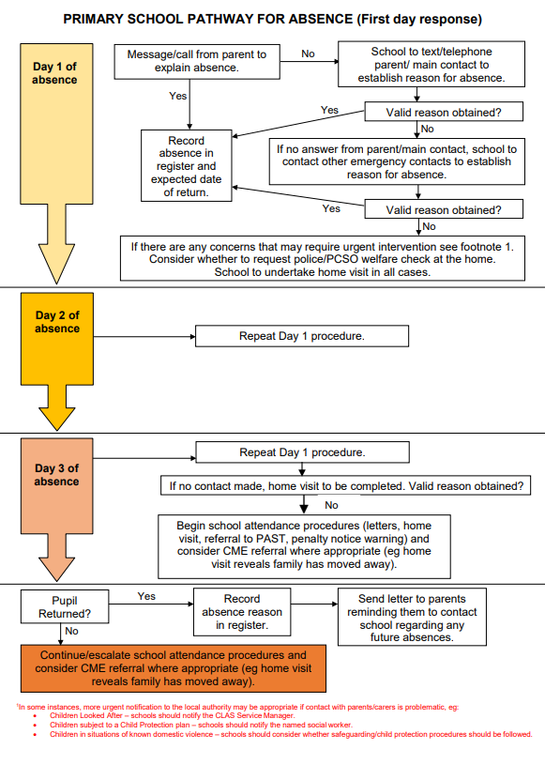

Traffic Light system

Every half term, every parent is notified of their child’s attendance through a report, created by Insight. (See below)

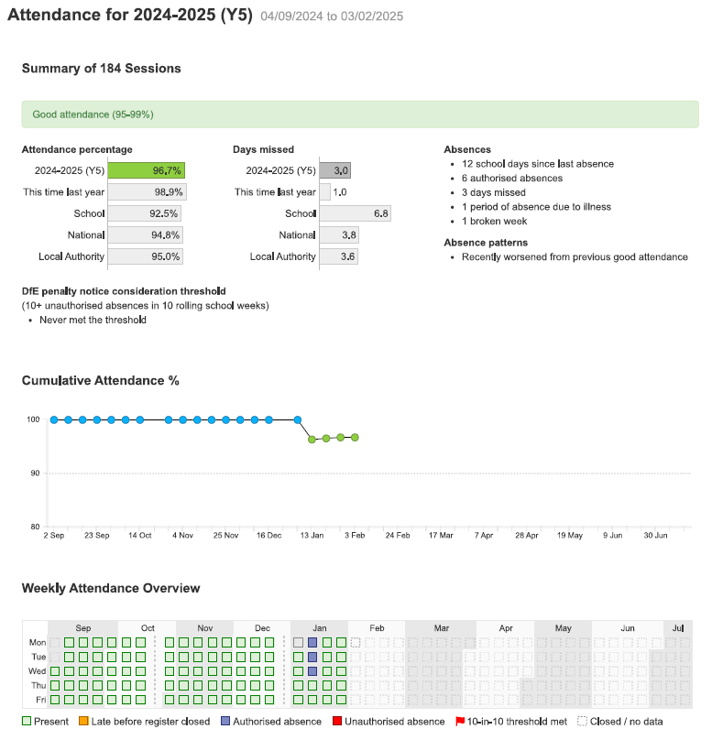

Attendance matters board

Every week, the class attendance is announced during the Headteacher’s assembly. Each class who achieves 96% or above, will roll the dice and move the relevant squares on the attendance matters board.

On certain squares, the classes can be rewarded with attendance rewards:

- Extra play times

- Hot chocolate/ice creams

- Computer/Ipad time

- Non-uniform days



