

Moor End Community
Primary School

RHSE policy 2024 - 27

Date of approval by Governors 7th March 2024

Contents
Introduction 3
Legal context 3
Definition* 3
Aims 4
Roles and responsibilities 5
Trustees/governors 5
Headteacher/principal 5
Subject leader 5
All staff 5
Curriculum organisation* 5
Teaching and learning 7
Curriculum content 8
Long term planning 8
Resources 8
Visitors 8
Equality 9
Right to withdraw from sex education* 9
Safeguarding 10
Support 10
Monitoring and evaluating* 11
Professional development 11
Communication of policy 11
Review* 11

Introduction
This is the policy of Moor End on the approach taken to Relationships, Sex and Health Education (RSHE), approved by governors on 07th March following a consultation with parents and carers March 2024.

Legal context
The law was changed with effect from September 2020 so that primary schools in England must teach relationships education and health education (The Children and Social Work Act 2017).
- The relationships education part of the new curriculum teaches what children need to learn to build positive and safe relationships with family and friends and online.
- The health education part of the new curriculum covers both physical health and mental wellbeing and teaches children how to make good decisions about their own health and wellbeing; how to recognise issues in themselves and in others; and how to seek support as early as possible when issues arise.

Sex education is not compulsory in primary schools, but:

- The new curriculum for relationships education and health education does include content on puberty.
- The national curriculum for science includes subject content in related areas, such as the main external body parts; the human body as it grows from birth to old age (including puberty); and reproduction in some plants and animals.

Following this change in the law, the Department for Education published Statutory Guidance for Relationships Education, Relationships and Sex Education (RSE) and Health Education (2019). This guidance requires primary schools in England to have a written relationships education policy to cover the following:

- How relationships education is delivered
- What sex education (if any) a school chooses to cover that goes beyond the national curriculum for science and relationships education.

There is no equivalent requirement for a health education policy but, in line with best practice, this RSHE policy also covers health education.

This RSHE policy also supports legal requirements relating to the following:

- The Equality Act 2010.
- The Education Act 1996.
- Statutory guidance, Keeping Children Safe in Education 2020.

Definition

RSHE supports children and young people’s personal development including their spiritual, moral, social and cultural development. Its aims are to help children and young people to deal with the real-life issues they face as they grow up and that they will encounter as adults. Their learning will support them both online and offline, to make informed choices about their safety, physical and mental health, enabling them to live positive and fulfilled lives.
RSHE is enhanced by a supportive school ethos where everyone is valued, positive relationships are promoted and there is a safe learning environment.

Ethos and Values

At Moor End Community Primary School we want to encourage and develop a love of learning, friendship and community for our pupils that will stay with them throughout their lives. We strive to combine the academic with the fun, encouraging independent learning; and have a developed curriculum that meets the needs of our children, in our community; preparing them for an ever-changing world. Our ethos is simple: if your child feels happy and safe they will enjoy school and learn to grow both academically and as a young person.

Sex and relationship education (SRE) will reflect the values of the PSHE and Citizenship programme. SRE will be taught in the context of relationships. In addition SRE will promote self-esteem and emotional health and well-being and help them form and maintain worthwhile and satisfying relationships, based on respect for themselves and for others, at home, school, work and in the community.

At Moor End, we aim to provide a holistic education for all children. Every pupil will receive their full entitlement to SRE regardless of their educational ability, gender, race, disability, sexual orientation, ethnicity or faith. We aim to support children in their emotional, cultural and social, as well as academic development.

Relevant local data and information related to SRE is used to inform planning and to address the identified needs of the whole school community e.g. teenage pregnancy and chlamydia rates, child sexual exploitation, domestic abuse, social deprivation, family life, career and life chances.

According to the Sex and Relationship Education Guidance, SRE is ‘lifelong learning about physical, moral and emotional development. It is about the understanding of the importance of loving and caring relationships.’

Aims

Contributing to the foundation of PSHE, the school’s SRE programme aims to ‘explore attitudes and values with children about relationships, emotions, self-esteem and personal safety.’ Children will develop skills in order to make positive decisions about their health-related behaviour. During SRE, children will ‘develop personal and social skills and a positive attitude to growing up’.

- Provide accurate and age-appropriate information.
- Include all children.
- Help children make informed choices.
- Develop knowledge, skills and attitudes.
- Build confidence and self-esteem.
- Develop personal attributes.
- Prepare children for the next stage of education and adulthood.
- Develop positive and inclusive attitudes to everyone, particularly to those with protected characteristics under the Equality Act 2010.

Roles and responsibilities
An effective programme of RSHE requires support from the whole school community and the following people have specific roles and responsibilities:

Trustees/governors
The governors have the strategic oversight when monitoring subjects across school PSHE and RSE are the same. This policy will be accepted in advance of the parent consultation.

Headteacher/principal
- Overseeing the development and delivery of RSHE.
- Providing staff with the opportunity to contribute to the development of RSHE.
- Providing information to the trustees/governors.
- Providing training for the subject leader and staff, as required.
- Supporting the subject leader to liaise with parents and carers.
- Dealing with parents and carers who wish to withdraw a child from sex education.

Subject leader
- Leading the development and delivery of effective RSHE.
- Keeping up-to-date with the development of RSHE.
- Supporting colleagues as required.
- Monitoring and evaluating RSHE and providing necessary reports.
- Liaising with parents and carers.
- Keeping subject information up-to-date, including on the school website.
- Overseeing external visitors and resources used in RSHE.

All staff
- To understand and implement the policy of RSHE.
- To teach RSHE in line with the agreed curriculum.
- To assess and monitor the progress of children.
- To respond to the needs of individual children.

Curriculum organisation*

The school adopts the following approaches to organise the curriculum to ensure high quality delivery of RSHE:

The school aims to provide a graduated, age-appropriate RSHE programme emphasising the social and emotional aspects of relationships.

Our RSE and PSHE scheme of work has been designed as a spiral curriculum with the following key principles in mind:
✓ Cyclical: Pupils revisit the five key areas throughout KS1 and KS2.
✓ Increasing depth: Each time a key area is revisited, it is covered with greater depth and increasing maturity.
✓ Prior knowledge: Upon returning to each key area, prior knowledge is utilised so pupils can build on
previous foundations, rather than starting again.
- RSHE to be covered as part of a wider programme of PSHE education.
- Lessons are delivered on a weekly basis.
- Length of RSHE lessons.
  - for KS1 – lessons should be 40 - 45 minutes long;
  - for KS2 – lessons should be 50 - 60 minutes long.
- At Moor End we use visit days and visitors to enhance our curriculum. For example- Rock Kidz

Our RSE & PSHE scheme of work is organised into units.

Within each most units, lessons should be taught in order as they build upon one another.
Across a single year group, units themselves do not need to be taught in the suggested order, apart from the Introductory lessons which are to be taught at the beginning of the year and the Transition lessons at the end of the year.

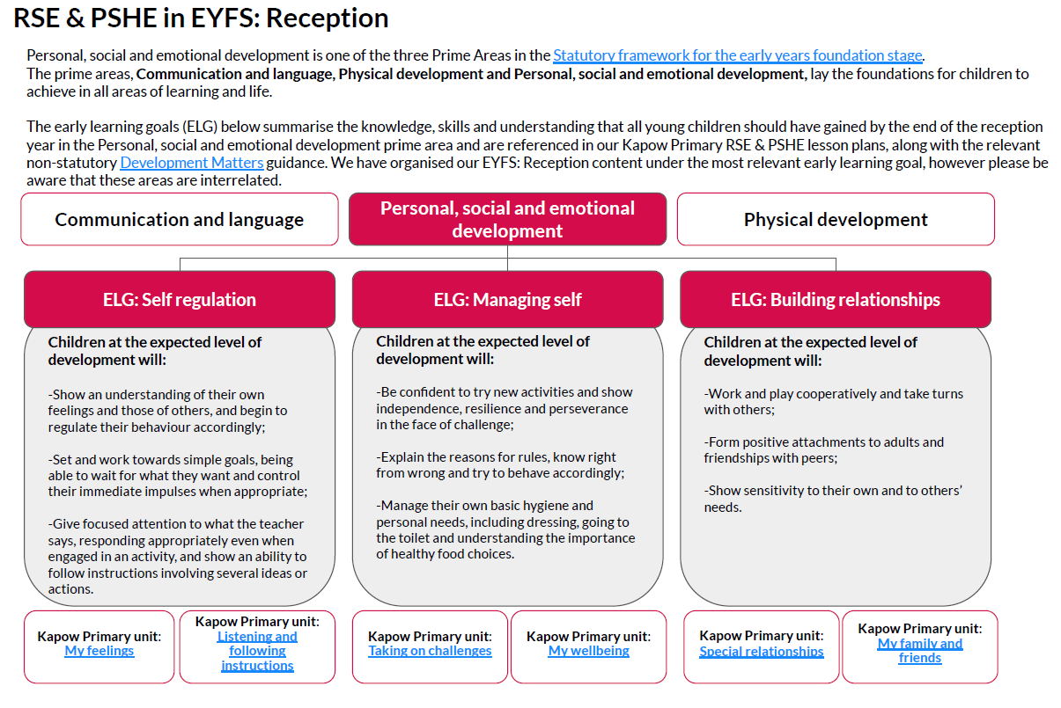
The flexibility in the order the units can be taught allows teachers to adapt the planning to suit their class and to cover particular units based on need at any moment in time.

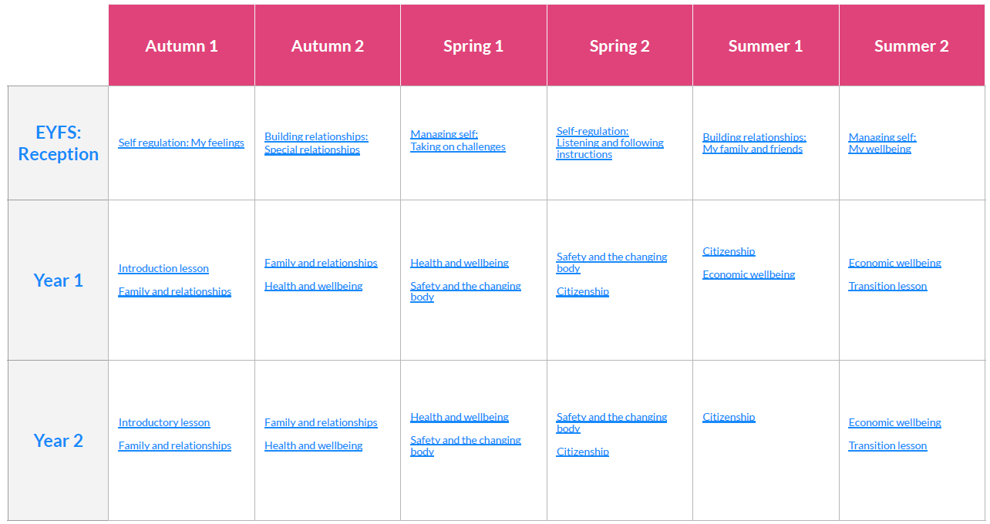
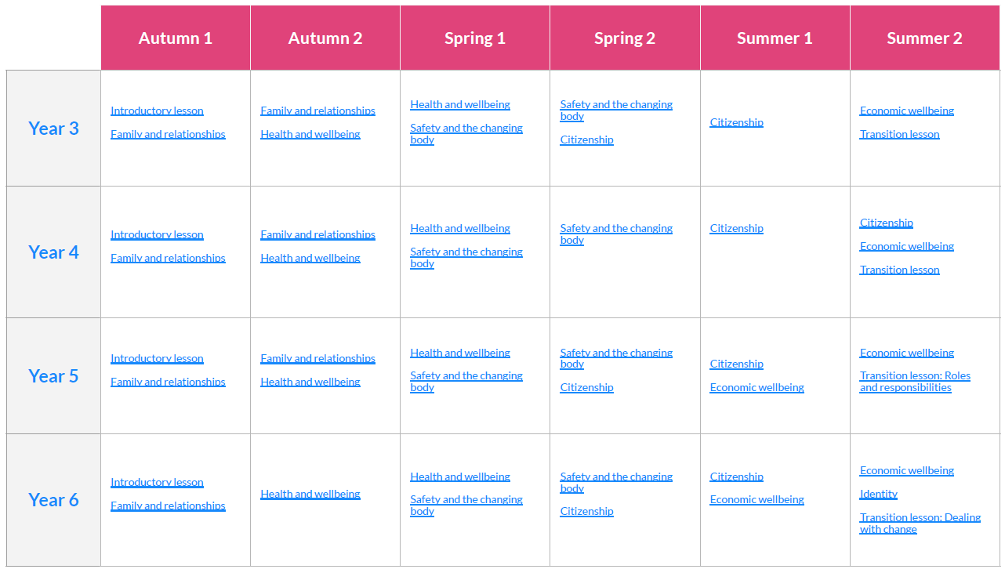

Teaching and learning

RSHE is delivered in line with the teaching and learning policy. However, as the subject deals with real-life experiences, it is important to establish a safe and positive learning environment using the following approaches:

- Establishing clear ground rules in consultation with children. Ground rules should include confidentiality, respect for others, privacy and boundaries.
- Using distancing techniques including de-personalised discussions and role play.
- Using clear language to avoid misunderstandings.
- Avoiding prejudice and assumptions about children’s abilities, desires, background and experiences.
- Dealing sensitively with unexpected questions and comments.
- Assessing and building on existing knowledge and experiences.
- Ensuring that learning is engaging, using a range of activities, including structured discussion and problem-solving.
- Providing a range of opportunities to learn, practise and demonstrate knowledge, skills and attitudes.
- Allowing time for reflection.
- Providing differentiated learning.
- Using a variety of groupings to enhance learning.

Curriculum content

Long term planning

The school has chosen to use the Kapow Primary RSE scheme of work, which provides full curriculum coverage, including all the statutory content, for each year group.

Follow this link to view the Kapow Primary RSE curriculum overview.

Resources

Teachers will select any additional resources carefully, and the subject leader will oversee the selection.

Additional resources will be:
- Up-to-date.
- Relevant to children.
- Consistent with the aims and values of the school.

Visitors

Visitors can enhance children’s learning. Teachers will select visitors in liaison with the subject leader. The following will be used to guide the use of visitors:

- The school will use visitors to enhance the lessons delivered by the class teacher; and information on where a visitor fits into the long-term plan will be shared with the visitor.
- The school will make visitors aware of the school policy for RSHE.
- The school will check the content of sessions delivered by visitors to make sure that it fits with the school’s ethos and meets legal requirements.
- A member of staff will be present in sessions delivered by visitors.
- The school will make sure visitors undergo the necessary checks as required by the school safeguarding policies.

Equality

Under the Equality Act 2010, the school is under a legal duty to eliminate discrimination, advance equality of opportunity and foster good relationships between those with protected characteristics and those without. The protected characteristics are:

- Age.
- Marriage and Civil partnership.
- Disability.
- Race.
- Religion and belief.
- Sexual orientation.
- Sex.
- Pregnancy and maternity.
- Gender reassignment.

In addition, the school must consider the needs of those with Special Educational Needs and Disabilities (SEND).

The RSHE programme will meet the needs of all children. Lessons will include content that will tackle discrimination and foster good relationships.

Right to withdraw from sex education

A parent or carer cannot legally withdraw their child from any aspect of the statutory relationships education or health education.

A parent or carer does have the right to withdraw their child from sex education unless what is being taught is part of the science national curriculum.

Following a consultation with the whole school community, the following content is deemed to be sex education:
The suggested Kapow Primary lessons that are deemed to be sex education are:

- Year 6: Safety and the changing body, Lesson 5: Conception
- Year 6: Safety and the changing body, Lesson 6: Pregnancy and birth

The following process must be followed if a parent or carer wishes to withdraw their child from sex education:

- All parents of children who are being taught sex education will have the relevant materials shared with them in advance
- If you have any concerns over what is being taught and would like to withdraw your child, you need to contact Mr Sumner via the school office.
- Following that, you will then be invited in to school for a meeting to discuss concerns and to outline the impact on the children of missing sex education lessons.
- If you want to continue with the withdrawal, the Headteacher will confirm and the information will be stored on CPOMS.

Safeguarding

RSHE includes sensitive topics. It is, therefore, possible that discussions will prompt safeguarding disclosures. Reference should be made to safeguarding policies and procedures to deal with these appropriately.

The subject leader/teacher should discuss with the designated safeguarding lead any potentially sensitive topics. Appropriate steps must be taken to provide additional support for children if required.

Staff should consider the timing of lessons to ensure that children have the opportunity to report any concerns they may have either that day or the following day.

Support

RSHE should not be a time for children to make disclosures. It is important, however, to inform children of the support that is available to them if they are worried about anything raised in a lesson. The children are fully aware of who the DSL’s are across school and the support they provide. They are also aware of the Laura, our learning mentor and what support she offers across school.

Teachers need to be aware that effective sex and relationship education, which brings an understanding of what is and is not acceptable in a relationship, may lead to disclosure of a child protection issue.

• The staff member will inform the Head Teacher /Designated Child Protection person in line with the LEA procedures for child protection.

• A member of staff cannot promise confidentiality if concerns exist.

Monitoring and evaluating*

The headteacher and subject leader will be responsible for monitoring and evaluating RSHE in line with other subjects. To ensure that the policy is adhered to and is effective, it will be monitored, reviewed and evaluated regularly. The school will assess the effectiveness of the aims, content and methods in promoting pupils’ learning by lesson observation, sampling teachers planning, questionnaires to teachers and children and feedback from parents. The effectiveness of the RSHE programme will be evaluated by assessing children’s learning and implementing change if required.

Professional development

The headteacher and subject leader will assess the professional development needs of staff regularly. Appropriate development will be provided using internal or external expertise.

Communication of policy

This RSHE policy will be available to read on and downloaded from the school website and copies can be requested free of charge from the school office.

Review

This policy will be reviewed every three years.

Date agreed with governors: 7th March 2024

Review date: September 2027

