Filtering and Monitoring

Why do we need a filtering and monitoring system?

The internet is now used daily in education and has become fundamental. It acts as a key learning tool for children however, it can also be an area for concern due to the nature of potentially harmful content available online.

There are many reasons why filtering and monitoring are required. In school the purpose is to ensure that children do not access unsuitable/inappropriate content. One example is around radicalisation. The Prevent Duty is a statutory obligation for schools to keep children safe from the risk of radicalisation and extremism. As a school, we are aware of the risks posed by the online activity of extremist groups, and how social media is being used to encourage young people to travel to certain countries.

Content filtering works by applying specific parameters to content retrieved via the internet, restricting access to certain materials on websites, Apps, emails or other suspicious items. It can be a hardware or software solution and can often be part of a firewall setting.

Monitoring combined with content filtering alerts for any activities that need to be acted upon, but the information is also used to determine which sites and keywords need to be filtered out. For example, if a new craze appears, the monitoring and filtering system will help us know what associated terms the children are searching for, and what websites they are accessing.

To safeguard and promote the welfare of our children, we provide them with a safe environment in which they can learn and flourish, by ensuring that they are not exposed to any online risks associated with using the internet. We have comprehensive filtering and monitoring systems in place for all devices used in school, and regularly review their effectiveness. Our school uses Netsweeper and this is monitored by our Senior Leaders and Governing body.

We also use the LGfL DigiSafe tool to assess wider online safety policy and practice.

Standard 1. - Identify and assign roles and responsibilities to manage school filtering and monitoring systems
Senior Leader Headteacher  Name: Philip Sumner | Safeguarding Governor:  Name: Lisa Hartley | Designated Safeguarding Lead:  Name: Laura Riedhalgh
Core Responsibility:  Responsible for ensuring these standards are met | Core Responsibility:  Strategic responsibility for filtering and monitoring, working with the headteacher to ensure that the standards are met. | Core Responsibility:  The DSL should take lead responsibility for online safety, working closely with IT service provider on day-to-day management of filtering and monitoring systems to ensure they meet the school's evolving safeguarding needs.  Headteacher has been delegated this responsibility.
Responsible For:  - Procuring filtering and monitoring systems  - Documenting decisions on what is blocked or allowed and why  - Reviewing the effectiveness of provision  - Overseeing reports  - Making sure that staff:  - understand their role  - are appropriately trained  - follow policies, processes and procedures  - act on reports and concerns | Responsible For:  - Identify a member of the senior leadership team, responsible for ensuring these standards are met  - Meet with identified senior leader to annually review provision  - Establish roles and responsibilities of relevant staff and third parties.  - make prompt changes to provision as required. | Responsible For:  - Overseeing and acting upon filtering and monitoring reports  - Responding swiftly and appropriately to safeguarding concerns  - Periodic checks to filtering and monitoring systems
IT Service provider  Name: LCC- Digital services | _____________________  Name: | _____________________  Name:
Core Responsibility:  Provide advice, training and technical support in maintaining the school's filtering and monitoring systems. | Core Responsibility:  Consider Admin Support or Data Controller | Core Responsibility:  Consider Admin Support or Data Controller
Responsible For:  - Day to day maintenance of filtering and monitoring systems  - Provide system specific training and support.  - Complete prompt, appropriate actions following concerns or checks to systems  - Work with the SLT and DSL to:  - procure systems  - identify risk  - carry out reviews  - carry out checks | Responsible For:  Providing administrative support for reports, management of blocked content and sites | Responsible For:  Ensure transparency when checking filtering on individual devices during randomized checks  Provide advice and support for GDPR related matters for devices

Standard 2. - Review filtering and monitoring provision at least annually.
Guidance:
- For filtering and monitoring to be effective it should meet the needs of pupils and staff and reflect your specific use of technology while minimising potential harms.
- To understand and evaluate the changing needs and potential risks to school, you should review your filtering and monitoring provision, at least annually.
- Additional checks to filtering and monitoring need to be informed by the review process so that governing bodies and proprietors have assurance that systems are working effectively and meeting safeguarding obligations.

The review should be done as a minimum annually, or when:
- a safeguarding risk is identified
- there is a change in working practice, like remote access or BYOD
- new technology is introduced

The review should be conducted by members of the SLT, the DSL and the IT service provider and involve the responsible governor.  The results of the online safety review should be recorded for reference and made available to those entitled to inspect that information. | Date of Review: 21/06/2025  Persons Undertaking Review: Philip Sumner (Headteacher) and Robert Burghiu (ICT technician)
As part of this review the South West Grid for Learning’s (SWGfL) testing tool was used to check that the filtering system is blocking access to illegal child sexual abuse material, unlawful terrorist content and adult content. The review committee noted the following log of checks undertaken since the previous review.
Date of Checks: 21/06/23 and 22/06.23  Checked By: Philip Sumner (Headteacher)  Screenshots may provide useful reference. | Equipment and User Groups Checked: Laptops and iPads.  Checks made on both staff and student accounts.  Netsweeper- reports sent on a weekly basis to Headteacher.  Reports are sent for suspicious activity:  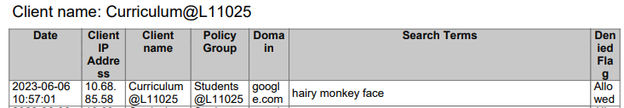  Reports are also sent for prevent:  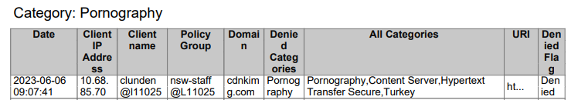  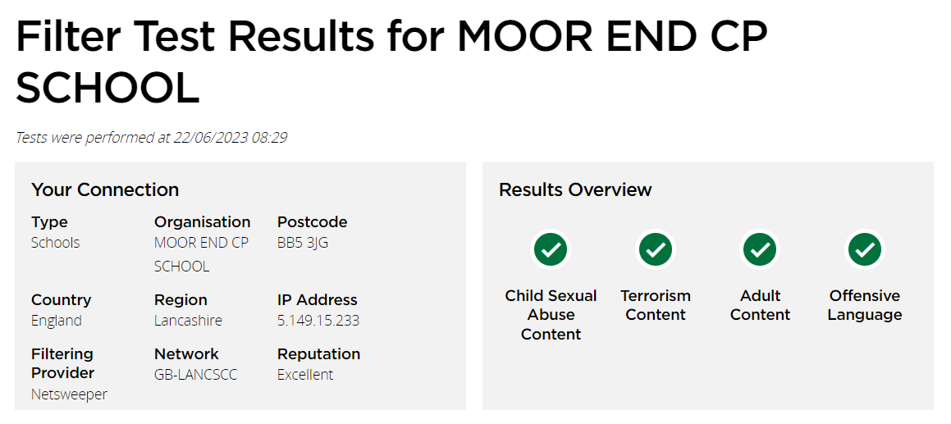  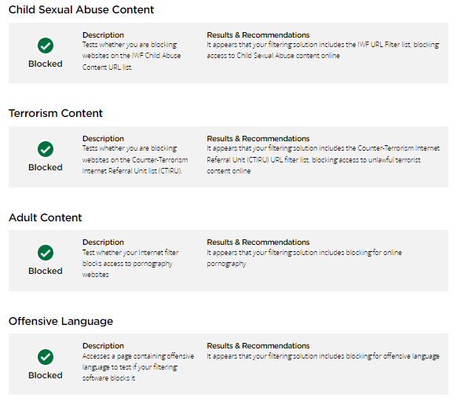  The checks should include a range of:  - school owned devices and services, including those used off site  - geographical areas across the site  - user groups, for example, teachers, pupils and guests  - ensure that guest access is correctly filtered including unlawful terrorist content as appropriate.
Actions Arising: | Monitor use of technology in Rising Stars.
Minutes of Review meeting:
A review of filtering and monitoring was carried out to identify our current provision, any gaps, and the specific needs of pupils and staff.
The following agenda was discussed:

Agenda:  - Risk profile of pupils, including age range, pupils (SEND), pupils with (EAL)  - What the filtering system currently blocks or allows and why  - Any outside safeguarding influences, such as county lines  - Any relevant safeguarding reports  - The digital resilience of pupils  - Teaching requirements, for example, your RHSE and PSHE curriculum  - The specific use of chosen technologies, including Bring Your Own Device (BYOD)  - What related safeguarding or technology policies are in place  - What checks are currently taking place and how are resulting actions handled | Notes:  - The filtering service is centrally hosted and managed with local filtering and reporting devolved to schools.  - It provides safe internet access for schools, managing all web content to our broadband connected schools.  - Netsweeper Filtering blocks all sites on the Internet Watch Foundation (IWF) CAIC list.  - Netsweeper filtering implements the Home Office Terrorism Block list.  SEND pupils at risk in Rising Stars- monitor usage and discuss with staff.  We have initially assigned a default filtering set based on school type Primary. This meets our needs. By default, this service blocks the following categories for all users:  Pornography  Child Sexual Abuse  Criminal Skills  Extreme  Hate Speech  Weapons  Viruses  Child Erotica  Gambling  Intimate Apparel  Marijuana  Substance Abuse  Malformed URL  Copyright Infringement  Malicious Web Obfuscation  Malware  Phishing  Web Proxy  Students can use school devices safely online away from school and receive the same level of web filtering as in school. All policies and logging will function in the same way as when in school.  All students taught internet safety through our RHSE and PSHE curriculum. We don’t just have one-off internet safety days. Instead it’s incorporated throughout our curriculum.
Actions arising in relation to:  - Related safeguarding or technology policies and procedures  - Roles and responsibilities  - Training of staff  - Curriculum and learning opportunities  - Procurement decisions  - How often and what is checked  - Monitoring strategies | Notes: Key actions and person responsible.  Mr Sumner- Headteacher and DSL to monitor usage and reports on a weekly basis.  Ensure all staff are up to date and have received current training, including new staff and volunteers through an induction handbook.
Has the filter system setup changed or been deactivated since previous check? NO
Do all staff know how to report and record concerns YES
Are all new devices and services checked for filtering and monitoring systems before release YES
Have blocklists been reviewed and modified as necessary in line with any changes to an identified risk YES

Standard 3. – The filtering system blocks harmful and inappropriate content, without unreasonably impacting teaching and
learning.
Guidance:
- No filtering system can be 100% effective. Schools need to understand the coverage of the filtering system, any limitations it has, and mitigate accordingly to minimise harm.
- An effective filtering system needs to block internet access to harmful sites and inappropriate content. It should not:
  - unreasonably impact teaching and learning or school administration
  - restrict students from learning how to assess and manage risk themselves
Nb Relevant Statutory Requirements:
Keeping children safe in education - GOV.UK (www.gov.uk)
Prevent duty guidance - GOV.UK (www.gov.uk)

Technical requirements to meet the standard.  Refer to the following core guidance  Appropriate Filtering - UK Safer Internet Centre  Check filters against the UKSIC checklists  Filter providers self-certification of systems using UKSIC checklist are available here.  Provider Checklists - UK Safer Internet Centre  Gain clarification from IT support and filter provider where necessary. | Is your filtering provider:  - a member of Internet Watch Foundation (IWF)  - signed up to Counter-Terrorism Internet Referral Unit list (CTIRU)  - blocking access to illegal content including child sexual abuse material (CSAM)  Is the filtering system operational, up to date and applied to all:  - users, including guest accounts  - school owned devices  - devices using the school broadband connection  The filtering system should:  - filter all internet feeds, including any backup connections  - be age and ability appropriate for the users, and be suitable for educational settings  - handle multilingual web content, images, common misspellings and abbreviations  - identify technologies and techniques that allow users to get around the filtering such as VPNs and proxy services and block them  - provide alerts when any web content has been blocked | Notes  Our Web Filtering & Online Protection (Netsweeper) service provides safe, filtered and logged web access for both staff and students for your school's broadband connection. It also provides a monitoring and alerting service that helps safeguard students. This service is an integral feature of our Broadband and Online Service Bundle.  It provides your school with the flexibility to locally manage, monitor and control access to websites. The service provides the following functionality:  Education focused web filtering.  Different filtering policies based on username, group membership or IP range.  Local control to allow your school to manage which websites and categories of websites it wishes to allow or block.  Monitoring and reporting on web access.  Meets the DfE recommendations for web filtering to protect pupils online and the standards for schools’ web filtering set by the UK Safe Internet centre.  Illegal content (as listed on the Internet watch Foundation) remains blocked at all times and access cannot be over-ridden by school staff.  Filters devices in school.  Provide student safeguarding by proactively monitoring student activities and real time alerting to the safeguarding lead in school when intervention is required.
Mobile and app content  Additional guidance is available.  UKSIC mobile devices - filtering and monitoring  Mobile and app content is often presented in a different way to web browser content.  A technical monitoring system should be applied to devices using mobile or app content to reduce the risk of harm | If users access Mobile APP content, has confirmation been obtained from the filter provider as to whether they can provide filtering on these mobile APP technologies.  Have SLT considered enforcing Safe Search, or a child friendly search engine or tools, to provide an additional level of protection for users on top of the filtering service? | Notes:  NB – LCC Digital Services can provide Mobile Device Management
Identification of Individuals  It is important to be able to identify individuals who might be trying to access unsuitable or illegal material so they can be supported by appropriate staff, such as the senior leadership team or the designated safeguarding lead.  Given the extent of personal data involved with some filter and monitoring solutions, Schools should consider undertaking a data protection impact assessment and ensure that the adopted strategy is integrated within organisational policies.  The DfE data protection toolkit includes guidance on privacy notices and DPIAs.  Data protection impact assessments | ICO | Does the filtering systems allow you to identify:  - device name or ID, IP address, and where possible, the individual  - the time and date of attempted access  - the search term or content being blocked  Has a data protection impact assessment (DPIA) been carried out in relation to the handling and protection of individual data/usage by the filtering system?  Have third party provider Privacy Policies been reviewed where available/applicable? | Notes:
Reporting mechanisms for safeguarding and technical concerns  All staff need to be aware of reporting mechanisms for safeguarding and technical concerns. | Do staff know how to report if:  - they witness or suspect unsuitable material has been accessed  - they can access unsuitable material  - they are teaching topics which could create unusual activity on the filtering logs  - there is failure in the software or abuse of the system  - there are perceived unreasonable restrictions that affect teaching and learning or administrative tasks  - they notice abbreviations or misspellings that allow access to restricted material | Notes:  Schools can configure and schedule their own reports of internet usage. These can be exported for further analysis e.g.  - Search Query Report: This report lists all of the search queries made by pupils and staff, which will list things like Google searches.  - Prevent Report – Websites: This report lists all of the websites which have been accessed which would fall under a Category which is contained within UK Prevent.  - Suspicious Search Report: This report lists all of the search queries which are identified by our Suspicious Search Keywords Shared List.  - User Inspection Report: This report shows all traffic from a particular User, which can be used to further investigate if a User has been highlighted as attempting to access content.  - Custom Report: This report has been created to give you more freedom to create custom reports. You are able to use this to create your own report along with customising most of the settings.

Standard 4. – Effective monitoring strategies are in place that meet the safeguarding needs of our school.
Guidance:
- Monitoring allows you to review user activity on school devices. For monitoring to be effective it must pick up incidents urgently, usually through alerts or observations, allowing you to take prompt action and record the outcome.
- A variety of monitoring strategies may be required to minimise safeguarding risks on internet connected devices and may include:
  - physically monitoring by staff watching screens of users
  - live supervision by staff on a console with device management software
  - network monitoring using log files of internet traffic and web access
  - individual device monitoring through software or third-party services

Technical requirements to meet the standard.  Refer to the following core guidance  Appropriate Monitoring - UK Safer Internet Centre |  |  | There are a range of monitoring strategies and systems, however, the appropriate monitoring strategy for individual schools should be informed by your risk assessment and circumstances.
Current Monitoring Strategy informed by previous Risk Assessment - (Highlight current strategy)
1) Physical Monitoring (low risk)  - Staff directly supervise children on a one-to-one ratio whilst using technology. ie physical supervision of children whilst using the Internet;  - Additional classroom support staff to monitor screen activity  - Actively monitoring all screen activity during a lesson from a central console using appropriate technology. |  | 2) Internet and web access logs (moderate risk)  - Internet Service Providers or filtering providers provide logfile information that details and attributes websites access and search term usage against individuals.  - Through regular monitoring, this information enables school to identify and intervene with issues concerning access or searches. |  | 3) Active/Pro-active technology monitoring services (High risk)  - Specialist services provide technology based monitoring systems that actively monitor network use through keywords and other indicators across devices.  - These can prove particularly effective in drawing attention to concerning behaviours, comms or access. May be:  - Active monitoring generating alerts for school to act upon.  - Pro-active monitoring where alerts are managed or supported by a specialist third-party provider.
Notes Regarding discussion of current strategy:

Does the chosen approach remain fit for purpose given any review of circumstances? YES
Have any incidents urgently been picked up, acted upon and outcomes are recorded. YES
Are all staff clear how to deal with incidents and who should lead on any actions. YES

Where device monitoring is managed by IT staff or third-party providers, have they:
Ensured monitoring systems are working as expected YES
Provided clear, adequate reporting on pupil device activity YES
Received safeguarding training including online safety YES
Correctly recorded and reported safeguarding concerns to the DSL YES
Ensured monitoring data is received in a format that staff can understand YES
Ensured users are identifiable to the school so concerns can be traced back to an individual, including guest accounts YES

If mobile APP technologies are used is a separate technical monitoring system used with these devices?  YES  Nb Filtering system may not pick up mobile or app content  Notes: |  | Does monitoring provision identify and alert you to behaviours associated with the 4 areas of risk identified within KCSIE. i.e.  Content: for example: pornography, fake news, racism, misogyny, self-harm, suicide, anti-Semitism, radicalisation, and extremism.  Contact: for example: peer to peer pressure, commercial advertising and adults posing as children or young adults with the intention to groom or exploit them for sexual, criminal, financial or other purposes.  Conduct: for example: making, sending and receiving explicit images (e.g. consensual and nonconsensual sharing of nudes and semi-nudes and/or pornography, sharing other explicit images and online bullying)  Commerce: for example: risks such as online gambling, inappropriate advertising, phishing and or financial scams.  YES  Technical monitoring systems do not stop unsafe activities on a device or online. Staff should also:  • provide effective supervision  • take steps to maintain awareness of how devices are being used by pupils  • report any safeguarding concerns to the DSL  Notes:
Are the school's monitoring procedures reflected in your Acceptable Use Policy and integrated into relevant online safety, safeguarding and organisational policies, such as privacy notices?

YES
Notes:

Has a data protection impact assessment (DPIA) been carried out in relation to the handling and protection of individual data/usage by any technical monitoring system?
Have third party provider Privacy Policies been reviewed where available/applicable?

NO
Notes:

