
Moor End Community Primary School

Positive behaviour policy 2025 - 26

Date of policy: Sep 2025

Date of review: Sep 2026

The MOOR END Way

At Moor End everything we do is for our pupils and is underpinned by our four ‘CARE’ values:

Confidence

Acceptance

Resilience

Enjoyment
Through these, it is our aim that every member of our school community feels valued and respected, and that each and every person is treated fairly and well. We pride ourselves on our caring and inclusive community whose principles are built on mutual trust and respect.
The understanding that children learn best within positive, trusting relationships informs our approach to managing and changing behaviour and we enable staff to work to identify pupils’ needs and provide developmentally appropriate support to remove these barriers to facilitate successful engagement in school life and beyond.
Our policy draws upon research in neuroscience, psychology and adverse childhood experiences and is inspired by the work of Paul Dix who published– ‘When adults change, everything changes’. It is underpinned by an expectation that by modelling, celebrating and recognising agreed positive behaviours, our children are ready to learn effectively.
At Moor End we have ensured our policy is centred around an overwhelmingly positive approach towards managing behaviour. The policy is based on a clear set of rules, incentives and rewards; and when required children will be explicitly taught how to behave in a positive manner - these will all be appropriate to the age and developmental stage of the children. This policy is also supported by our work on our PSHE / PSED Curriculum including My Happy Mind and our work towards achieving the Lancashire Behaviour Quality Mark– having good behaviour is key to gaining and maintaining high standards in each of these initiatives.
Our response to behaviour recognises that our children are unique and individual and that some will require additional support in order to achieve the high expectations we have of behaviour for all children. We aim to actively promote high self-esteem and high aspirations for all pupils, through an ethos that values every child. For children, being able to manage and understand their emotions, to apply thinking between feeling and action, and to increasingly show empathy and understanding to others is core to our work.
Trauma Informed Practice
An understanding of trauma and childhood adversity also significantly informs our approach to relationships within our school community. We are committed to ensuring that our school develops a trauma and mental health informed approach to ensure that all our children develop positive mental health and resilience, enabling them to fully engage in life and learning. There is a growing body of research and understanding of the impact of childhood adversity on long-term mental and physical health and the protective factors that mitigate the potential impact. It is our aim to maximise the protective factors of school by creating an environment of safety that has strong, positive and supportive relationships at its heart.

Our Core Beliefs
‘What you praise gets repeated’
We believe positive, targeted praise is more likely to change behaviour than blaming and punishing. Reinforcing good behaviour helps children feel good about themselves. An effective reward system and celebrating success helps to further increase children’s self-esteem enabling them to achieve even more. Understanding each child’s needs and their individual circumstances helps us to act in the fairest way possible for that child, at that moment.
We recognise that clear structures of predictable outcomes have the best impact on behaviour. Our school’s principles for behaviour sets out the rules, relentless routines and visible consistencies that all children and staff follow.
Our Expectations
We expect our school community to follow our ‘rule of three:’
We are Ready
We are Respectful
We are Safe

These rules are explicitly taught and modelled by all members of our school community. When dealing with any inappropriate incidents, it is important to refer to the school expectation that has not been adhered to as an anchor point. Similarly, where appropriate, when acknowledging a positive action or response it is important to also refer to the school expectation or core value that has been demonstrated.
However, we also understand that for some children, following our behaviour expectations are beyond their current developmental level. In this case, these children will have access to bespoke positive behaviour plans, which may include carefully targeted sanctions and rewards to reinforce positive behaviour.
We understand that our principles require the presence of positive relationships. Staff and pupil relationships must be built on mutual respect and trust in the same way that we expect that pupil’s relationships with peers to be built upon respect, trust, friendship and tolerance for each other’s wishes.
Our Approach
Promoting Positive Behaviour at Moor End
We believe that behaviours that are positively rewarded are more likely to be repeated and so we feel it is important that the children enjoy a wide range of positive consequences across each and every day at school.
Rewarding Positive Behaviour
We praise and reward children for positive behaviour in a variety of ways:
• Our four teams; Red, Blue, Yellow & Green ensure that all pupils belong to a team, with two Team Captain representatives. We use our team approach so our children know that their positive attitude and behaviour is for more than individual recognition as it is for the good of all. Pupils will be awarded Team Tokens for demonstrating being Ready, Respectful and Safe. These are collected and once a team has filled their ‘section’ they will be rewarded with a collective treat decided by our Team Captains.
• Children can earn individual team points for behaviour and learning in school
• Staff praising those children who go over and above
• Staff give out stickers and stamps
• Class recognition boards
• Hot Chocolate Friday with the Head
• ‘Top Table’ for positive lunchtime behaviour
• Children show other staff members when they have done something well
• Children receive certificates in the school assembly for positive behaviours
• Class celebration assemblies to show examples of best work
• Half termly Golden ticket award
• Parents / carers are invited to celebration assemblies
• Children are actively encouraged to share their achievements out of school during weekly celebration assemblies.
- Positive phone calls home
• Children awarded various roles and responsibilities in school
Visible Adult Consistencies
These are the visible behaviours exhibited by staff and which are consistent, and can be expected by children. Through these consistencies, adults will build respectful relationships with pupils. Inconsistency teaches pupils that boundaries are flexible which can encourage further misbehaviour.
• Children are greeted at the classroom door and/or in the classroom, daily by their teacher and/or teaching assistant. This enables everyone to start the day positively and with a smile. Members of the Leadership Team and/or support staff will also meet and greet children and parents at the gate or in other areas of the school.
• Staff will be calm, consistent and fair in their treatment of children, parents and colleagues. Adults in school will avoid shouting at children or becoming emotionally charged. They will model self-control through their calm approach and will deal with individuals fairly.
• Staff will ‘pay first attention to the best conduct’ and will endeavour to catch children ‘doing the right thing’ in order to praise and recognise desired behaviours. This encourages children to be role models and makes expectations on behaviour clear for all.
Relentless Routines
These routines, consistently seen and heard around school, will ensure all pupils are clear about the behaviour expectations of all adults.
• Pupils and adults will contribute to our ‘Calm Corridors’ and uphold a high level of expectation when moving around school. Pupils and adults will move quietly through the corridors demonstrating ‘Proud Walking’ and will remain on the left.
- After break pupils will demonstrate ‘Smart Lines’ where they stand silently, one behind the other and facing the way they are going. These ‘Smart Lines’ will be used on entry and exit from the assembly hall and when moving around school as a whole class.

- ‘One Voice’- Pupils and staff will Be Respectful to the speaker by ensuring they do not talk over them. This ensures ‘one voice’ is heard at once and turns are taken to speak so that everyone feels valued in the discussion or conversation. Hands-up will be the appropriate signal for a pupil wanting a turn to speak.
• When adults in school require the full attention of a class or group of children, they will use key actions such as ‘Team Stop’ which is one had raised in the air or ‘Silent Countdown’ where the adult counts backwards from 5 to 0. Pupils are taught to stop what they are doing, turn to face the adult and Be Ready to listen. This ensures a quiet and calm classroom where the teacher can address pupils at the same time.
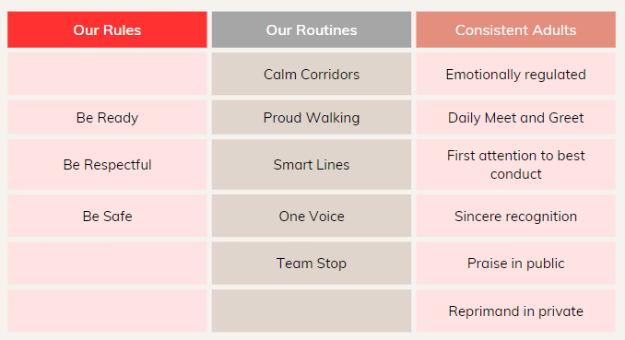

Undesirable Behaviour
From time to time pupils may display unacceptable behaviours. These will be consistently handled by all staff so that all pupils are safe and happy at school and learning can take place which is not disrupted. All adults will use positive behaviour management techniques which allows children to correct their behaviours. Children are made aware of the behaviour system at the beginning of the school year and are reminded of the expectations regularly.
Consequences
'Punishment doesn't teach better behaviour, restorative conversations do.'
Paul Dix

All behaviour - both positive and negative, have consequences. All negative behaviour that is in breach of the school rules results in negative consequences for the pupil who has made the wrong choice. When pupils behave incorrectly this will be dealt with promptly, predictably and with confidence to maintain a calm and safe learning environment for all.
The main consequence is a breakdown in a relationship that then needs work to restore it through reflection and restorative conversations.
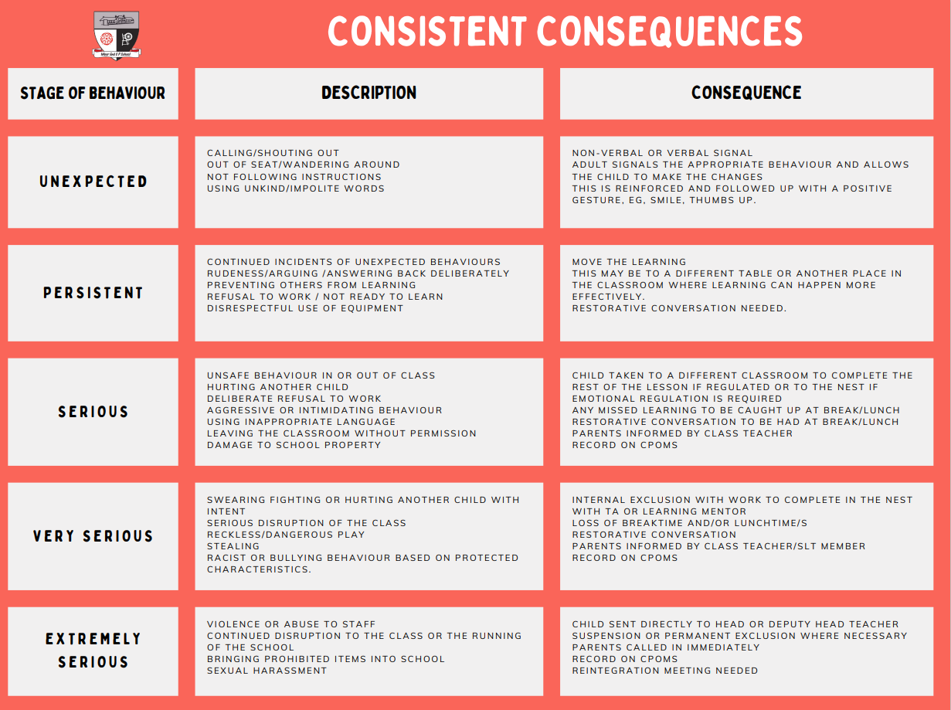
*TA should escort the pupil out to The Nest leaving the class teacher able to continue teaching.

Should an adult feel, using their professional judgement, that a senior member of staff needs to be part of the Follow up/Restorative Conversation then the following guidelines should be used:
Pupil is taken to the Class Teacher > Learning Mentor > Behaviour Lead > Key Stage Lead > Deputy Headteacher> Headteacher (in that order)
Other natural consequences may be to tidy up a mess they have made, fix something that has been broken or miss the next task because the previous one has not been done. We employ each consequence appropriately (reasonably and proportionately) to each individual situation and each one is designed to be restorative in its approach and results in a reduction of the inappropriate behaviour.
Other types of consequence:
• Loss of privileges
• Reflection room- lunchtime area for restorative conversations to happen
• Written tasks such as account of behaviour/letter of apology
• ‘Check ins’ with a senior member of staff
• Spoken to by the deputy/head teacher
• Meeting with parents
• Restorative work around school
• Working in another area of school

If a child has repeated incidents requiring reflection in a short time frame or a pattern of behaviour is becoming apparent, a meeting with Classteacher/SLT/Pastoral Team and parents/carers will be arranged.

This will be recorded on CPOMS.

To maintain effective relationships and consistent adult behaviour we will strive to avoid:

• humiliation
• shouting
• over reacting
• blanket punishment
• harsh sarcasm
• using an area of the curriculum as a punishment

Playtimes and Lunchtimes
Our playgrounds are places of fun, socialising and crucial outdoor, exploratory learning. Our staff team are trained to understand the core fundamentals of playtime as an extended learning time to develop personal and physical skills.
Staff ensure that children enjoy a safe and happy time outdoors and identify concerns with behaviour quickly to catch moments as a teaching opportunity. On occasions, where children are displaying behaviours which are not safe, being unkind to others or not following our rule of three, staff act quickly. Where incidents of serious misbehaviour occur leaders are alerted and a plan is placed around the child. The following may be put into place to support:
- Withdrawn from certain playground zones for a period of time
- Separation of certain individuals
- Withdrawn from play/lunch for a period of time while restorative work takes place in our reflection room
- A playtime plan placed around the child with certain provision such as a key adult, an early end time from the yard or specific areas to play
- Protected Play – in the quad
The adult dealing with the event will inform the teacher who will gauge whether communication with the parent/carer is necessary. Incidents will be logged on CPOMS so that patterns in behaviour can be identified by senior leaders.
Extremely Serious Behaviours
Occasionally, some children may behave in a way which is out of character for them. Extremely serious behaviours may be expedited through our ‘Consistent Consequences’ in order to be dealt with more quickly by a member of SLT. If this occurs a focussed meeting involving SLT and the staff members will be arranged to discuss what happened. However, it is important to maintain that all adults can deal with these types of behaviour.
Unacceptable behaviours may include:
• Violence (i.e. physical contact made with the intention to harm)
• Defiance / rudeness towards any adult
• Persistent taunting, teasing and bullying behaviour
• Stealing
• Spitting
• Swearing
Exclusions
Internal Exclusion
An internal exclusion may be appropriate if a child displays ongoing behavioural concerns. This will involve the child spending their time in school away from other pupils. An Internal Exclusion will be supervised, under the direction of a member of the schools Senior Leadership Team (SLT).
Managed Moves
After following the above steps, the possibility of a managed move could be offered to parents to avoid further escalation. This would involve liaising with another cluster school, who might possibly have space to take the child.

Exclusions
Exclusion of pupils is the ultimate sanction. This is a sanction that may be used if other systems have not been effective or in case of extreme behaviour. The following are examples of behaviour which will not be tolerated and warrant a possible exclusion:
- Extreme or violent abuse to a member of staff or another child.
- Long-term or repeated misbehaviour that is not responding to strategies in place and the safety and learning of others is being seriously hindered.
- The risk to staff and other children is too high.
- The impact on staff, children and learning is too high.
Exclusions take the form of fixed term or permanent exclusion. A fixed term exclusion may take the form of a lunchtime exclusion, implementation of a part-time timetable or an exclusion for a designated number of days.
All pupil exclusions at Moor End Primary School are reported appropriately to the Local Authority and follow Local Authority and National guidelines for administration and legal responsibility.
If a child is at risk of exclusion, parents will be notified and invited to a meeting with the Headteacher to try to support the school and pupil to avoid the situation deteriorating and to put a plan in place to improve pupil behaviour.
The headteacher can take a decision to exclude a pupil in response to serious breaches of a school's behaviour policy, where allowing your child to remain in school would seriously harm the education and welfare of your child or others in the school.
https://www.lancashire.gov.uk/children-education-families/schools/exclusions-from-school/
Permanent exclusion will always be a last resort and the school will endeavour to work with the family to complete a managed move to a more suitable setting where possible. In all instances, what is best for the child will be at the heart of all decisions making processes.
Determining when use of restrictive interventions is appropriate
There will be times when school staff may need to use restrictive interventions, and they should know this option may be available to them. The decision on whether it is reasonable to use a restrictive intervention depends on the individual circumstances of each situation. To make this assessment, the member of staff should consider the following:
Is it necessary?
• Staff should consider whether there are other more effective, less restrictive ways to manage a situation.
• Staff should assess whether a restrictive intervention is likely to successfully reduce the relevant risks, or whether its use would escalate the situation further or cause more harm than the behaviour itself.
• Where possible, staff should communicate with other staff members to understand any broader risks in the environment.
Is it proportionate?
• Staff should use the least amount of force or least restrictive intervention necessary for the least amount of time required to reduce the relevant risks.
• If the intervention itself is escalating the situation, staff should reconsider their approach and attempt an alternative strategy.
• Staff should consider the personal circumstances of the pupil such as medical conditions, special educational needs or other vulnerabilities, their characteristics such as age and size, and must consider relevant equality implications under the Equality Act 2010.14

Have you considered the pupil’s welfare?
• Staff should consider the impact on the pupil’s overall welfare, balanced against any actions taken. For example, pupils who have experienced an adverse life event, with diagnosed or undiagnosed medical conditions or sensory impairments, past trauma or neglect, communication difficulties, or other needs, may find the use of restrictive interventions particularly distressing.
• Staff should seek to maintain respect for a pupil’s dignity. This may include, where possible, considering the location and environment where any intervention is used, such as in front of their peers.
• Where possible, staff should clearly and calmly communicate to the pupil what is happening, why, and explain what the pupil needs to do.
• For pupils with difficulties with speech, language and communication, or with English as an additional language, verbal and/or non-verbal strategies should be used to ensure the pupil understands what is happening and has adequate time to process information and respond.
• Staff should seek to understand how the pupil is feeling and use this information to determine whether the restrictive intervention should be, or continue to be, applied, reduced or stopped.
This list of factors is not exhaustive, and staff should also take into account other relevant considerations. Training on the use of restrictive interventions should equip staff to judge when it is appropriate to use restrictive interventions, including in situations where quick decisions are needed. It should also help staff understand how to assess whether their response is reasonable under pressure.
If an assessment has been made to use restrictive interventions, staff should be supported in their decision making.
Consideration for pupils with special educational needs and/or disabilities (SEND)
Some children and young people with SEND may react to distressing or confusing situations by displaying behaviours which may be harmful to themselves and others. Triggers may include pain, sensory overload, unfamiliar situations or environments or feelings of fear and anxiety. In particular, pupils who are non-verbal or find verbal communication challenging may express their needs, discomfort or confusion through actions. This can lead to pupils with SEND being disproportionately subject to the use of restrictive interventions.
Schools should seek to understand the underlying triggers of challenging behaviour so that they can provide proactive support, create an inclusive environment and consider the impact of school policies on pupils with SEND. For example, schools should consider how the school culture and environment may be experienced differently by pupils with SEND and seek to support pupils to cope with situations that they may find distressing.
Schools should utilise staff who know individual pupils well to help identify and manage risk such as trigger points when challenging behaviour is more likely to occur, and develop proactive strategies to reduce the likelihood of restrictive interventions being used. They should also work with the pupil, parents and other professionals to develop prevention and de-escalation strategies.
Depending on the circumstances, examples of strategies may include:
• removing stimuli that may be causing distress
• changing body language, facial expression, and/or tone of voice
• supporting the pupil to express their emotions before getting overwhelmed
• engaging the pupil in an activity which can help them manage their feelings of anxiety
• distracting the pupil in something that interests them or by introducing familiar objects and activities to redirect their attention
Where appropriate, school staff should work with pupils with SEND and their parents in the co-production of any necessary behaviour support plans. Behaviour support plans should outline any adjustments, such as to address aspects of the school environment which the pupil finds challenging and ways for pupils to communicate their needs effectively.
Behaviour support plans should detail circumstances where it may be appropriate for staff to have increased physical contact with a pupil. This should be discussed in conjunction with the relevant people, such as teachers, parents, the pupil, pastoral staff or health professionals, and parameters around its use stated clearly in the plan. Where there is an identified risk, such as increased likelihood in the need to use reasonable force and/or other restrictive interventions, schools must have risk assessments in place and where possible, mitigate risks such as through training and prevention strategies. Whether the use of restrictive interventions is appropriate will depend on the circumstances, irrespective of whether it has been considered as part of a behaviour support plan.
Any behaviour support plans should be reviewed with the pupil and their parent periodically and following any significant incident, so that changes can be made based on evidence of what has worked and what has not worked in practice for the individual pupil. Where a pupil has a disability, the school has a duty under the Equality Act 2010 to take reasonable steps to avoid disadvantage so that the pupil can fully participate in the education provided by the school, and that they can enjoy the other benefits, facilities and services that the school provides for pupils.
For more information, please see the link below for guidance:
Use of reasonable force and other restrictive interventions guidance
SPECIAL EDUCATIONAL NEEDS AND BEHAVIOURAL DIFFICULTIES
In managing behavioural difficulties, the school will have regard to the SEND (Special Educational Needs and Disabilities) Code of Practice and will strive to ensure that children’s special learning needs are identified and met through a support plan.
As an inclusive school, we recognise that for some children, additional or different actions may be necessary as a result of a special educational need and/or disability.
Support may be sought from external agencies for children identified as having special needs resulting in emotional and behavioural difficulties.
PREVENTING BULLYING
Bullying is defined as behaviour by an individual or group, repeated over time, that intentionally hurts another individual or group either physically or emotionally.
Our Anti-bullying policy outlines the procedures which the school takes in instances of bullying.
In order to prevent bullying, we proactively gather intelligence about issues between pupils which might provoke conflict and develop strategies to prevent bullying occurring in the first place through promoting acceptance and understanding. This might involve talking to pupils about issues of difference, perhaps in lessons, through dedicated events or projects, or through assemblies.
Our school ‘CARE’ values support and encourage the positive behaviour and relationships we teach. Our values permeate the whole school environment and are reinforced by staff and older children who set a good example for the rest.
CHILD ON CHILD ABUSE
This form of abuse is when there is any kind of physical, sexual, emotional or financial abuse or coercive control exercised between children/young people both on and offline. It is essential that all staff understand the importance of challenging inappropriate behaviours between children/young people. Downplaying certain behaviours, for example dismissing sexual harassment as “just banter”, “just having a laugh”, “part of growing up” or “boys being boys”; or not recognising that emotional bullying can sometimes be more damaging than physical harm and should be taken equally seriously, can lead to a culture of unacceptable behaviours, an unsafe environment for children and in worst case scenarios, a culture that normalises abuse leading to children/young people accepting it as normal and not coming forward to report it. Stopping harm and ensuring immediate safety is an education setting’s first priority.
CONFISCATION OF INAPPROPRIATE ITEMS
Staff have the power to search pupils without consent for ‘prohibited items’ and confiscate these if necessary. These items include (but are not limited to):
- Knives and weapons.
- Alcohol.
- Illegal drugs.
- Stolen items.
- Tobacco and cigarette papers.
- Pornographic images.
- Any item that has been or is likely to be used to commit an offence, cause personal injury or damage to property.
- Any item banned by the school rules which has been identified in the rules as an item which may be searched for including mobile phones.
The headteacher will oversee the school’s practice of searching to ensure that a culture of safe, proportionate and appropriate searching is maintained, which safeguards the welfare of all pupils and staff with support from the designated safeguarding lead (or deputy). The designated safeguarding lead (or deputy) should be informed of any searching incidents where the member of staff had reasonable grounds to suspect a pupil was in possession of a prohibited item.
Where will the search be completed: An appropriate location for the search should be found. Where possible, this should be away from other pupils. The search must only take place on the school premises or where the member of staff has lawful control or charge of the pupil, for example on a school trip.
Who will carry out the search: The law states the member of staff conducting the search must be of the same sex as the pupil being searched. There must be another member of staff present as a witness to the search. This will usually be DSL’s in school.
When searching, staff will ensure they follow the DFE guidance here: Searching, Screening and Confiscation
If parents need children to have a mobile phone for use during the journey home, they should send give their permission through either a letter to the school office or via Seesaw. The phones must be stored either with their class teacher or the Headteacher in a secure area.
If staff have concerns/suspicions regarding any of the above items being in a child’s possession, they should seek advice from Headteacher/Deputy Headteacher who will take the appropriate action.
The Headteacher will decide if and when to return an item, or whether to dispose of it.
The role of our families
At Moor End, active family involvement is welcomed, appreciated and deliberately encouraged in order to:
• ensure that children attend school regularly, arriving on time, alert and ready for the tasks ahead and are collected, promptly, at the end of the day;
• understand and reinforce the school routines and language as much as possible;
• share in the concern about standards of behaviour generally;
• support the work of the school as staff seek to support the whole family.
We will always aim to contact families quickly when there are concerns about deteriorating levels of acceptable behaviour. However, staff will not routinely contact or inform families of minor digressions.
The Headteacher:
• It is the responsibility of the Headteacher to implement the school behaviour policy consistently throughout the school, and to report to governors, when requested, on the effectiveness of the policy.
• It is also the responsibility of the Head teacher to ensure the health, safety and welfare of all children in the school. The Head teacher supports the staff by implementing the policy, by setting the expectations of behaviour, and by supporting staff in their implementation of the policy.
• The Headteacher ensures that all reported serious incidents of misbehaviour are recorded.
• The Headteacher has the responsibility for giving fixed-term exclusions to individual children for serious acts of misbehaviour. For repeated or very serious behaviours, the Head teacher may permanently exclude a child. These actions are taken only after the school governors have been notified.

Governors Statement of Principles
Moor End Primary School has high expectations of its pupils. Our high expectations of behaviour apply at all times, with all people and in all places, not only during the school day but beyond in the wider community and whilst online.
The purpose of the behaviour policy is to enable everyone – parents, pupils, staff, governors and other members of the school community to share responsibility for creating an atmosphere, which enables children to manage, and self-regulate their own behaviour.
We recognise the need for high expectations of behaviour, the importance of consistent systems for improving challenging behaviour, the value of rewarding positive behaviour and the benefits of restorative practice.
Consultation, monitoring and evaluation
The Headteacher monitors the effectiveness of this policy on a regular basis. The Headteacher reports to the governing body on the effectiveness of the policy and, if necessary, makes recommendations for further improvements.
It is the responsibility of the governing body to monitor the rate of suspensions and exclusions, and to ensure that the school policy is administered fairly and consistently. The governing body will pay particular attention to matters of racial equality; it will seek to ensure that the school abides by the non-statutory guidance The Duty to Promote Race Equality: A Guide For Schools, and that no child is treated unfairly because of race or ethnic background.
The governing body reviews this policy every two years. The governors may, however, review the policy earlier than this if the government introduces new regulations, or if the governing body receives recommendations on how the policy might be improved.
Useful Links
Use of reasonable force and other restrictive interventions guidance
https://www.gov.uk/government/publications/use-of-reasonable-force-in-schools https://assets.publishing.service.gov.uk/government/uploads/system/uploads/attachment_data/file/674416/Se arching_screening_and_confiscation.pdf https://assets.publishing.service.gov.uk/government/uploads/system/uploads/attachment_data/file/641418/20 170831_Exclusion_Stat_guidance_Web_version.pdf https://assets.publishing.service.gov.uk/government/uploads/system/uploads/attachment_data/file/835733/Ke eping_children_safe_in_education_2019.pdf https://assets.publishing.service.gov.uk/government/uploads/system/uploads/attachment_data/file/398815/SE ND_Code_of_Practice_January_2015.pdf https://assets.publishing.service.gov.uk/government/uploads/system/uploads/attachment_data/file/488034/Be haviour_and_Discipline_in_Schools_-_A_guide_for_headteachers_and_School_Staff.pdf https://assets.publishing.service.gov.uk/government/uploads/system/uploads/attachment_data/file/571640/Ge tting_the_simple_things_right_Charlie_Taylor_s_behaviour_checklists.pdf
Legislative links
Education Act 1996
School Standards and Framework Act 1998 Education Act 2002
Education and Inspections Act 2006
School Information (England) Regulations 2008 Equality Act 2010
The Education (Independent School Standards) (Amended) (England) Regulations 2014 Education Act 2011
Schools (Specification and Disposal of Articles) Regulations 2012
The School Behaviour (Determination and Publicising of Measures in Academies) Regulations 2012 Keeping children safe in Education 2022

